Aspen iAnalytics™ User Guide:
Reports Design
For ALL Aspen iAnalytics™ Users
Aspen Grove Solutions

Contents
1.0 Introduction to Aspen iAnalytics™ Reports 6
1.1 Report List 7
1.2 Report Designer 8
1.3 Report Viewer 9
1.4 Dashboard Viewer 10
2.0 Report List and Dashboards 11
2.1 Report Tiles 12
2.2 Categories 13
2.3 Dashboards 14
2.3.1 View an Existing Dashboard 14
2.3.2 Create a New Dashboard 14
2.3.3 Adding Report Parts to the Dashboard Tile 15
2.3.4 Moving & Resizing Dashboard Tiles 18
2.3.5 Tile Customizations 19
2.3.6 Main Dashboard Menu 21
3.0 Data Sources Tab 23
3.1 Advanced Mode 24
3.1.1 Join Types 25
3.1.2 Function Buttons of Data Sources Tab 26
4.0 Fields Tab 27
4.1 Description 30
4.2 Sort, VG, & Arithmetic Check Boxes 31
4.3 Analysis Grid 32
4.4 Field Order and Advanced Field Controls 35
4.5 Functions Drop-Down 36
4.5.1 Numeric Formats Available 38
4.5.2 Date/Time Formats Available 39
4.6 Advanced Field Settings Button 40
4.7 Expressions 42
4.7.1 Three Ways to Apply an Expression to a Field 43
4.7.2 Text Concatenation 44
4.7.3 Using [brackets] to call [table].[field] 45
4.7.4 Ratios 45
4.7.5 Caution: The Limits of Expressions 46
4.7.6 Functions 47
4.8 Quick Add 48
4.9 Add Pivot 49
5.0 Filters Tab 51
5.1.1 Filter Field Dropdown Menu 51
5.1.2 Filter Operator Dropdown Menu and Value(s) 52
5.1.3 Operator Categories 52
5.1.4 Blank Param & Required Checkboxes 54
5.1.5 Other Buttons on the filters tab 55
5.1.6 Other Filter Features 55
5.1.7 Alias Filter Field Names 56
6.0 Summary Tab 57
7.0 Chart Tab 58
7.1.1 None Selection 58
7.2 Trend Selection 59
7.2.1 Creating a Trend Chart showing Orders by Month 60
7.2.2 Creating an Advanced Trend Chart Report 62
7.3 Pie Chart 63
7.3.1 Creating a Pie Chart showing the percentage of orders from each country 63
7.3.2 Creating an Advanced Pie Chart Report 66
7.4 Bar Charts 68
7.4.1 Example Bar Chart 68
7.4.2 Create a Bar Chart Showing the Top 15 Countries 70
7.4.3 Create a Bar Chart with a Separator 71
7.4.4 Other Bar Chart Options 73
7.5 Funnel Chart 76
7.6 Visualizations 77
7.6.1 Arc Map 79
7.6.2 Auto Chart 79
7.6.3 Combo 79
7.6.4 Crossfilter 80
7.6.5 Heat Map 80
7.6.6 Matrix 80
7.6.7 Projected Map 81
7.6.8 Sunburst 81
7.6.9 Time Bubble 81
7.6.10 Timeline 81
7.6.11 Transitions 82
7.6.12 Waterfall 82
7.6.13 World Tour 82
7.6.14 Auto Gauge 82
7.6.15 Calendar 82
7.6.16 Flow Chart / Data Tree 83
8.0 Gauge Tab 84
8.1 Create First Four Gauges Alphabetically Counting Orders by Country 87
8.2 Creating the Top 4 Orders by Country Gauges 88
8.3 Changing Color Ranges 89
8.3.1 KPI’s and auto-updating data with Animated Gauges 92
8.4 Gauges with Drill-Down Effects 94
9.0 Aspen iAnalytic™ Maps 95
10.0 Misc Tab 97
10.1 Share With & Rights 99
10.2 Drilldowns and Subreporting 100
10.3 Scheduler 102
10.3.1 How to Set Up the Aspen iAnalytics™ Scheduler 103
10.0 Style Tab 104
10.1 Style Properties 105

1.0 Introduction to Aspen iAnalytics™ Reports

Aspen iAnalytics™ Reports enables you to easily access your data directly and quickly transform raw data into useful and readily understood information.

With Aspen iAnalytics™, you can:
- Extract the information you need from one or more related tables.
- Format data into tables, reports, charts, pivots, and gauges.
- View the resulting report in your Web-browser and then print it.
- Export reports in several formats, including Microsoft Word, Microsoft Excel, and Adobe PDF.
- Automate many processes through scheduling, sharing, alerting, batch processing, and caching.
- Implement custom layout reports through Forms.
- Develop user-defined or custom Dashboards and Maps.

Aspen iAnalytics™ point-and-click interface is designed for the standard business user, with Advanced options available for those with greater access and skill. Many users will never design reports, but simply make modifications to current core reports, or use drill-downs to start at a high-level overview and click through to get to the required information.

This user manual will step you through each simple process in using Aspen iAnalytics™, and provide you with what you need to know to create your queries and reports. Any data that your application developer has included in the database can be accessible to you in creating ad hoc reports.

Report List

The Report List is where all visible reports are displayed to and interacted with by end users.

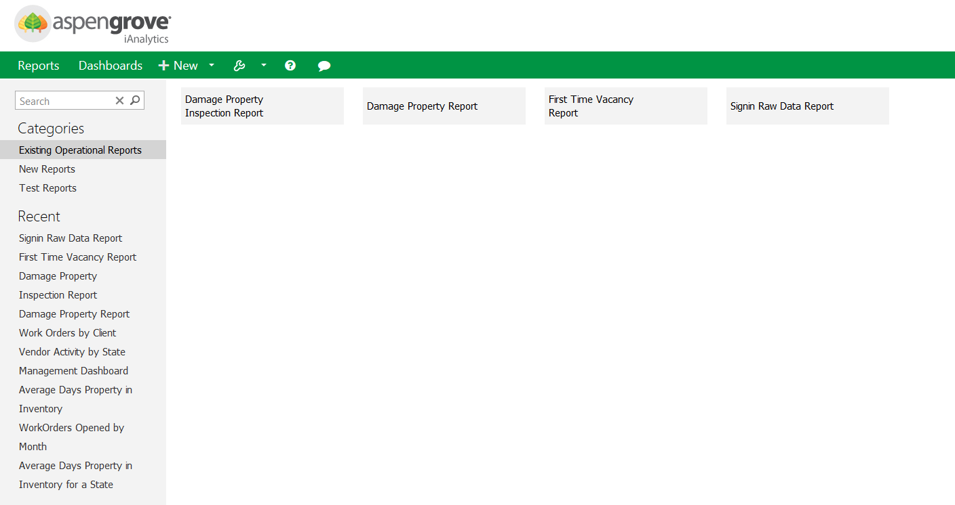

Report Designer

The Report Designer lets you create new reports and modify existing reports. The Report Designer is used for making all permanent changes to a report, as well as engaging with all the complex features of Aspen iAnalytics™ Reports.

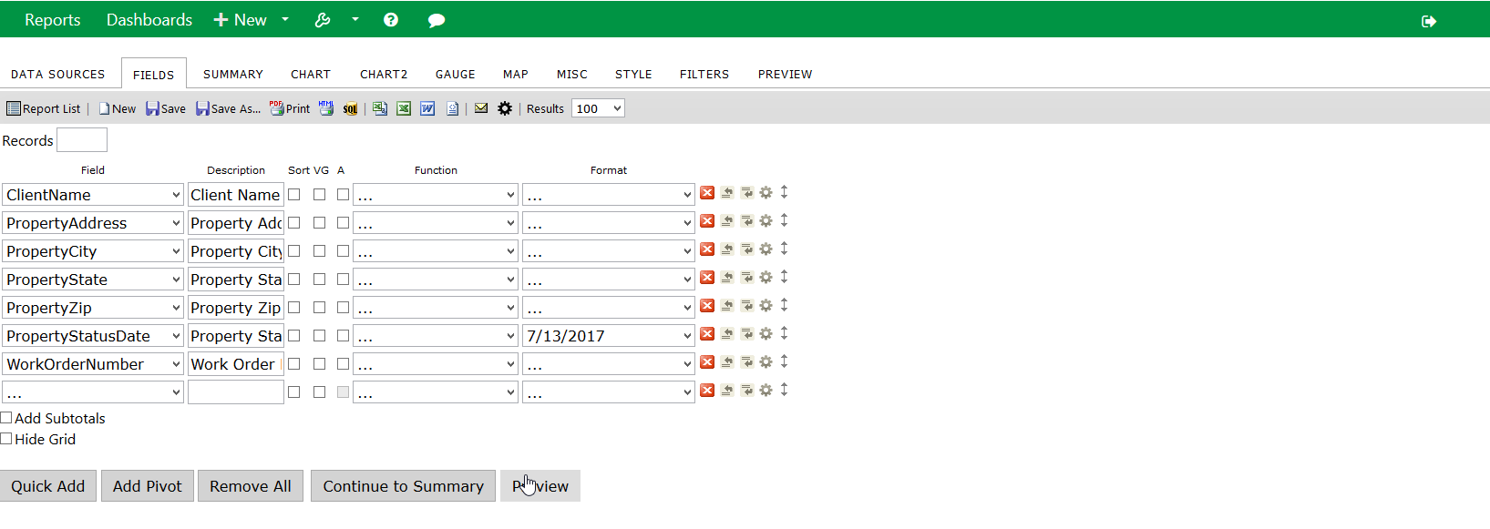

Report Designer – Fields Tab

Report Viewer

The Report Viewer lets you look at and modify existing any report, save a variation, print it, export to various formats, and share it through email.

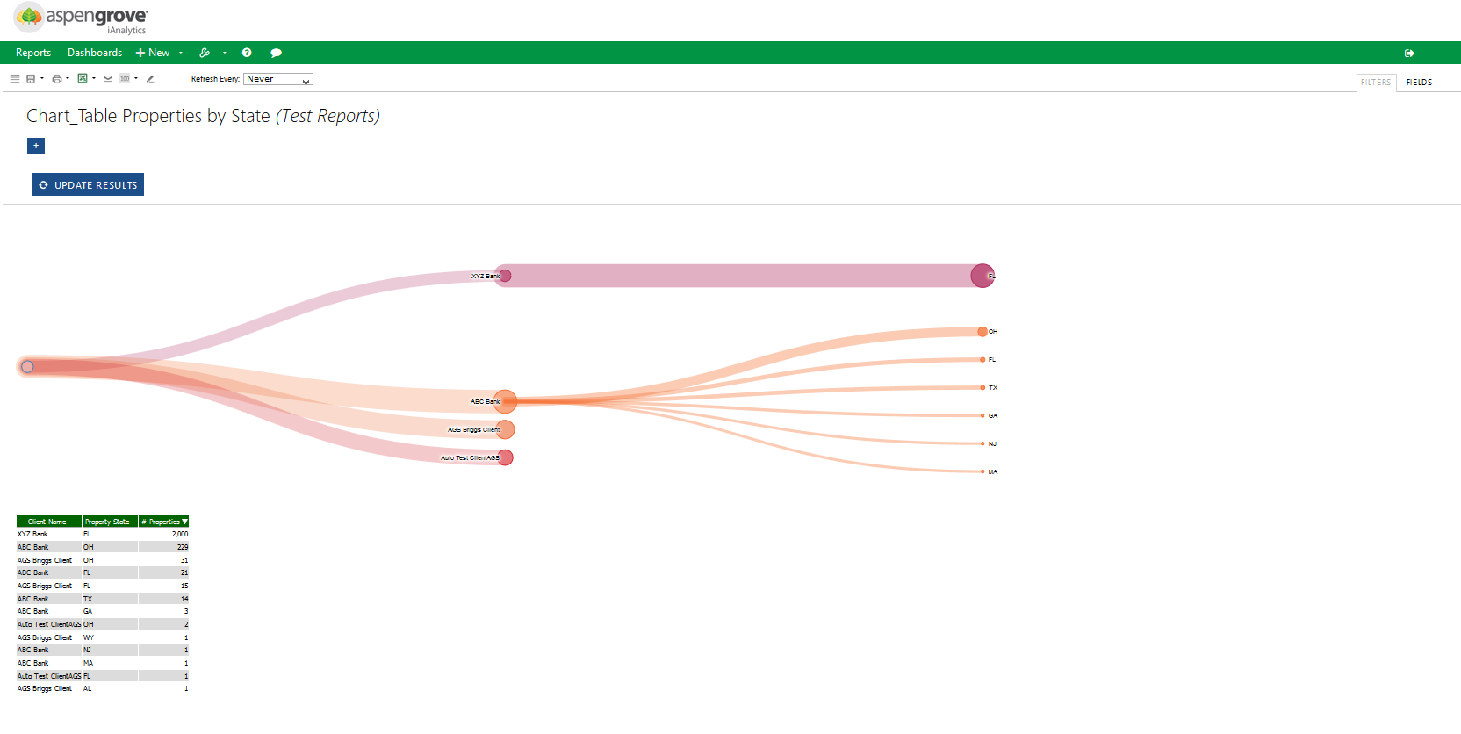
Report Viewer Showing Chart, Fields, and Visual Groups

Dashboard Viewer

The Dashboard Viewer is used to view and create Dashboards, which are assembled from parts of existing iAnalytic reports.

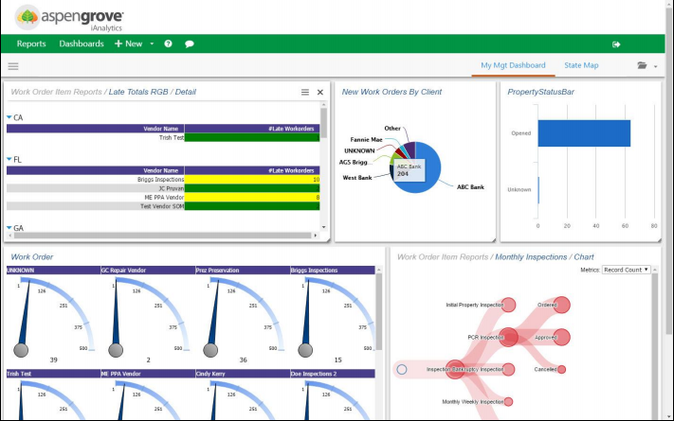
Dashboard Viewer

Report List and Dashboards
The Default Aspen iAnalytics™ Report List shows reports arranged alphabetically by category.
Across the top toolbar we can see a list of all Reports, a list of all Dashboards, and the +New button, which permits the creation of a new Report, a new Dashboard, or a new Instant Report.
On the left side of the Report List is a search bar, the Categories listing which shows all Categories listed alphabetically, and the recent reports list, which is populated by the most recently viewed reports.
Default Report List

Report Tiles

Hovering over an individual report tile makes certain buttons appear. Clicking anywhere on the report tile other than these icons loads this report in the Report Viewer.
The top right X icon deletes a report, assuming you have permission to do so. If not, this button may not appear.
The bottom right pencil icon takes you directly to the Report Designer, assuming you have permission to access it. If not, this button may not appear.
The bottom printer icon prints the report directly, as it was the last time it was refreshed.
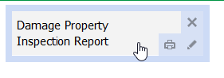
Report Tile and Icons

Categories

Categories are internal organizational structures which Aspen iAnalytics™ uses to help you keep track of your reports. When a report is saved, you will have the option to create a new category or to save a report in an existing category. Categories do not exist objectively, they only exist in relation to an object stored within them – in other words, if there are no reports or dashboards within a category, that category will be culled. If reports are not visible to you because of security or permissions settings, then those categories will also not be visible.

Dashboards

Dashboards are collections of report parts. You can pull one or more parts of one or more reports into a dashboard and arrange them in a custom manner.

View an Existing Dashboard
Click on ‘Dashboards’ on the Navigation Bar. Dashboards will be displayed as tabs in the window with the active Dashboard tab highlighted.

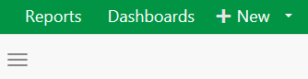
Navigation Bar

Dashboards will also appear in the default Report List alongside reports. You can save Dashboards in their own categories in order to keep them distinct from reports.

Create a New Dashboard
Click on the arrow to expose the drop-down menu under ‘New’, then select Dashboard from the Menu drop down, or click on the three horizontal line icon and click the plus sign for New Dashboard.
A New Blank Dashboard will be exposed with a single blank tile. Click on the + sign to add a Report Part to the initial tile.

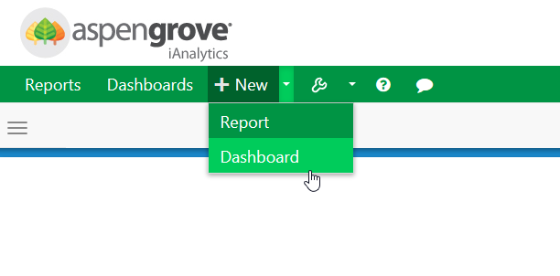
Creating a new Dashboard
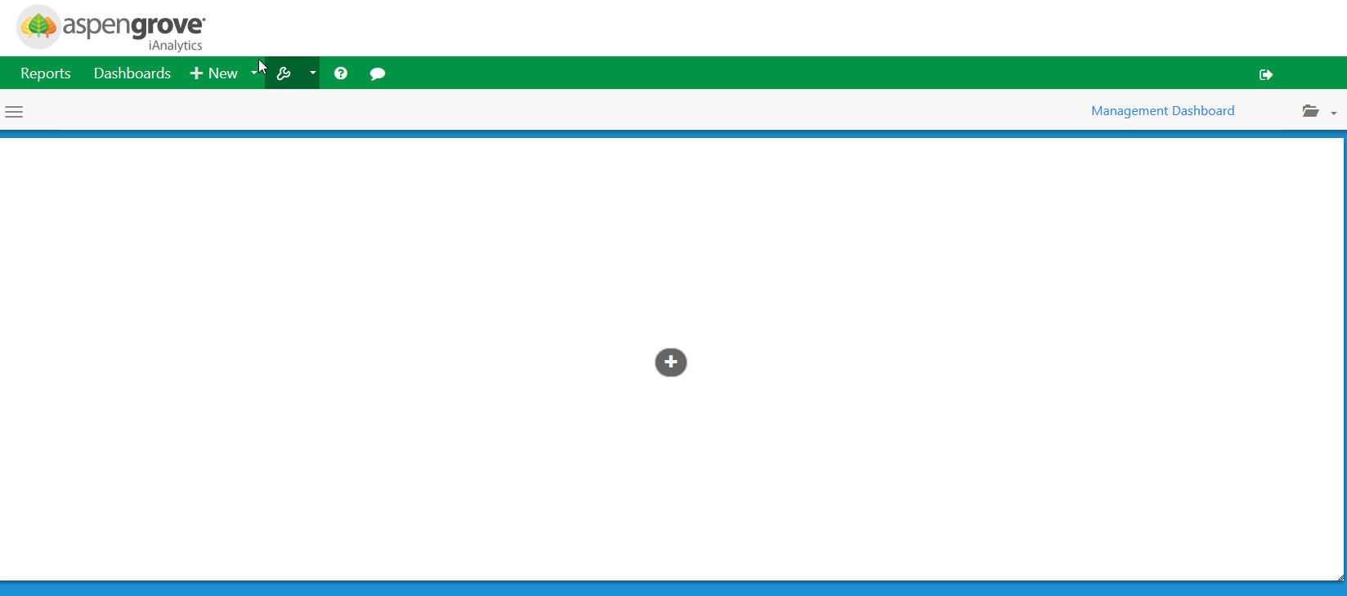
The new Dashboard with a single exposed tile

A New window will be displayed allowing you to select the report part to add to the dashboard, as well as modify initial properties about this report part such as where it comes from and what it is titled.

Adding Report Parts to the Dashboard Tile
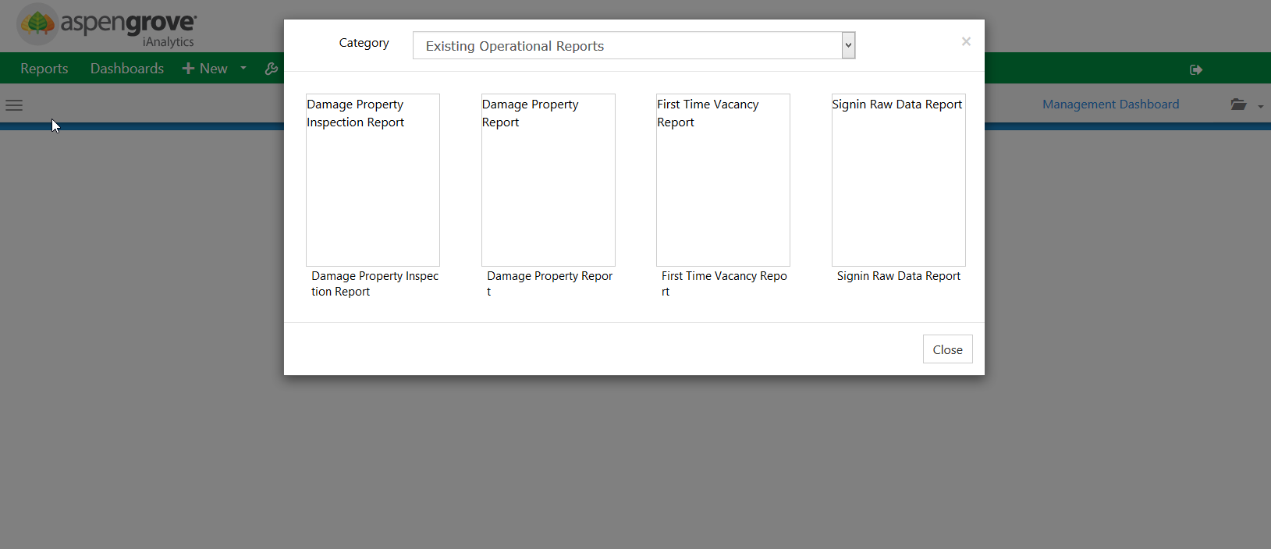
Selecting a Report to provide a Report Part for this tile

You can now select a report to use in the dashboard. Once a report is selected, you will be shown a window displaying all of the report parts as options to add to the new dashboard. These can include charts, maps, summaries or report details. Each tab on the report designer that has content controls an individual report part.
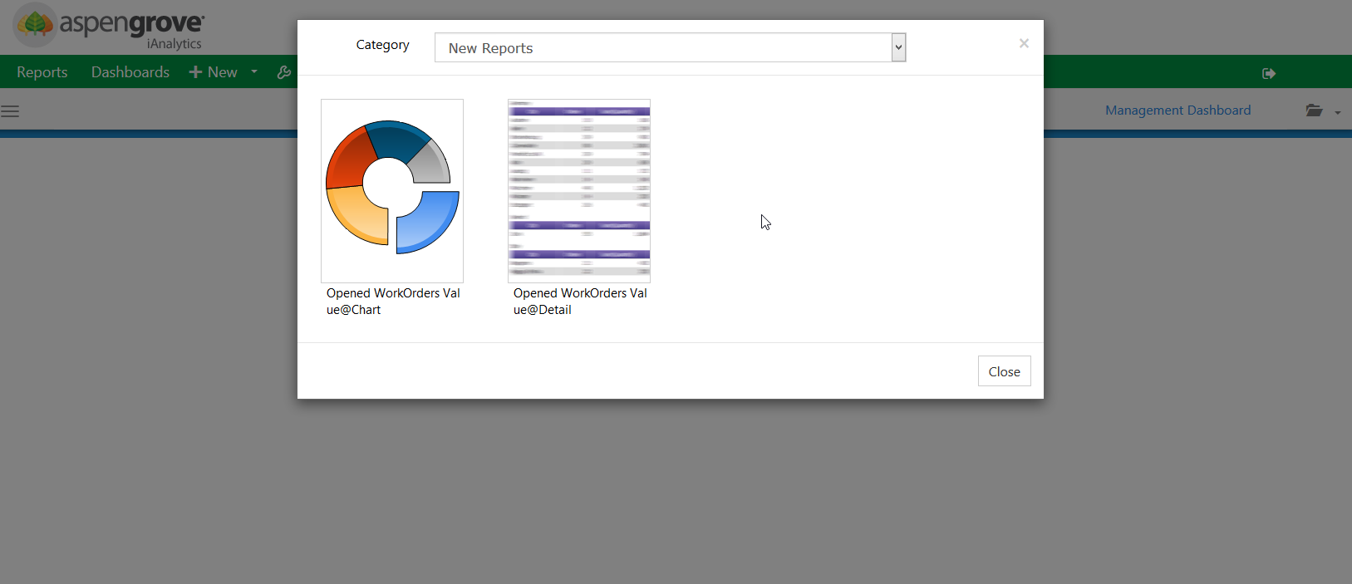
Selecting a Report Part
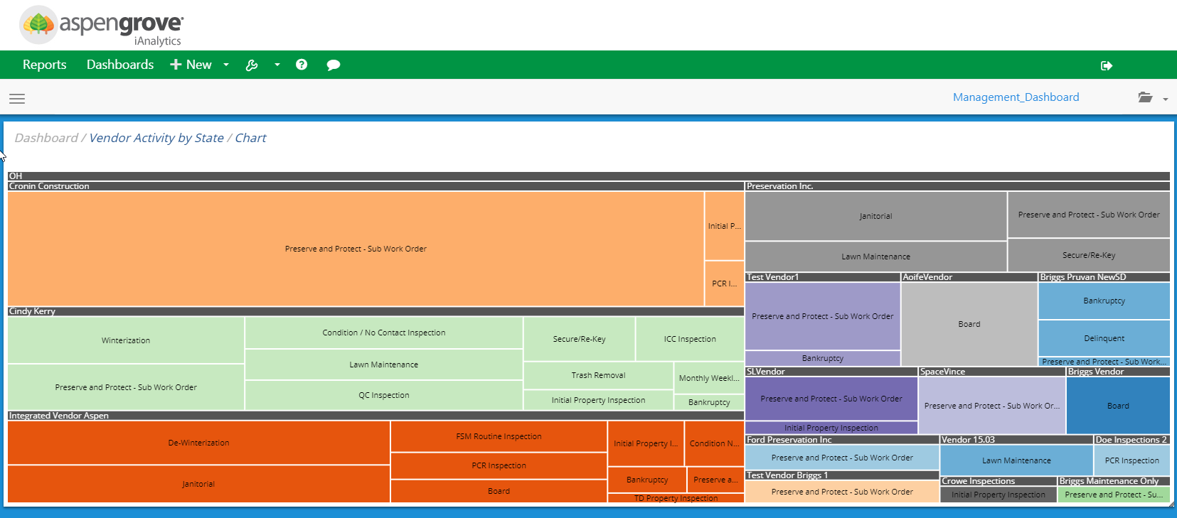
A tile containing a Report Part
The report part selected will then be displayed. To add additional tiles to the dashboard, the user can click on a blank area of the dashboard background. A new blank tile will then be created.
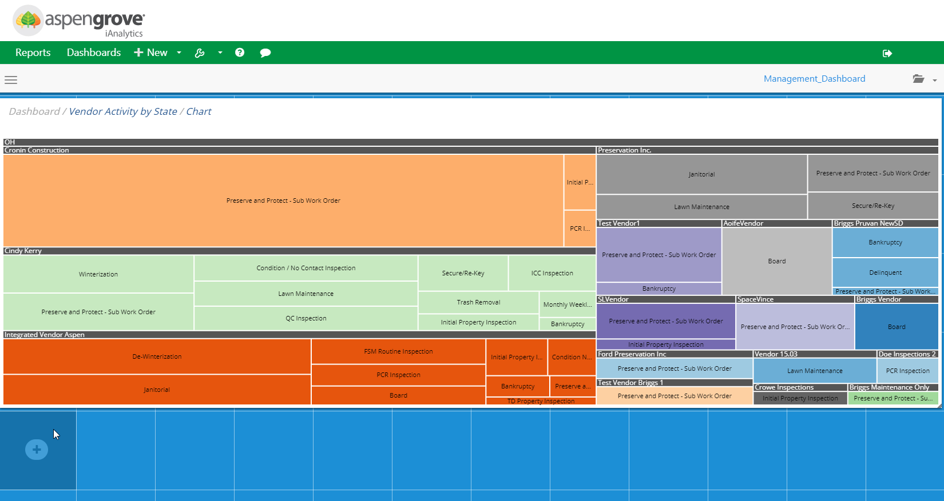
Adding another tile to a Dashboard
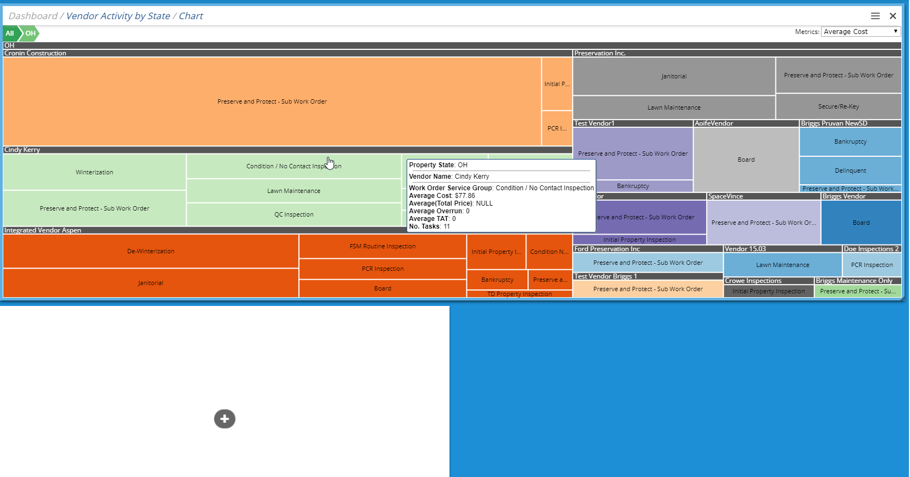
A new tile created beneath an existing tile

Moving & Resizing Dashboard Tiles
The tiles can be resized by dragging the corners of the tile to the desired length or width.
Tiles can also be moved around the Dashboard. When the tile shows a green hue, it is positioned correctly and can placed on the grid. If the tile shows a red hue, it is not positioned on the grid properly and cannot be moved.
Properly Positioned Tile for move (green hue)
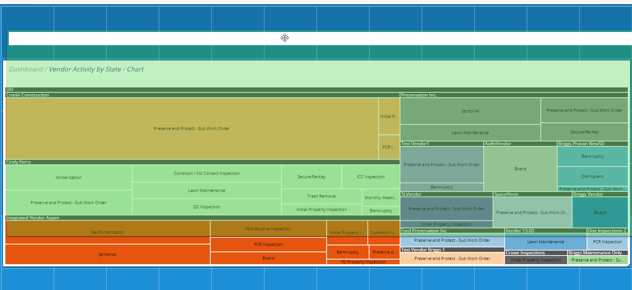
Properly Positioned Tile for move (green hue)

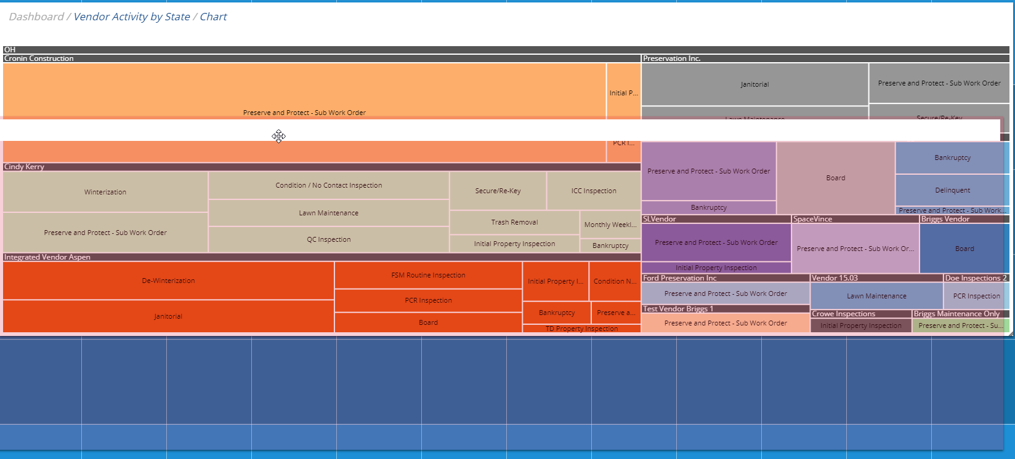
Improperly Placed Tile for move (red hue)

Tile Customizations
There are several options available to customize a tile. These options can be found by clicking on the menu button in the top right corner of the specific tile. The tile will then spin around, revealing the tile options menu. To remove a tile, simply click the “X” in the top right corner of the tile.
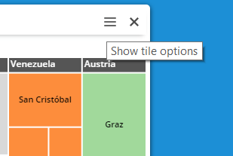
To show tile options or delete a tile
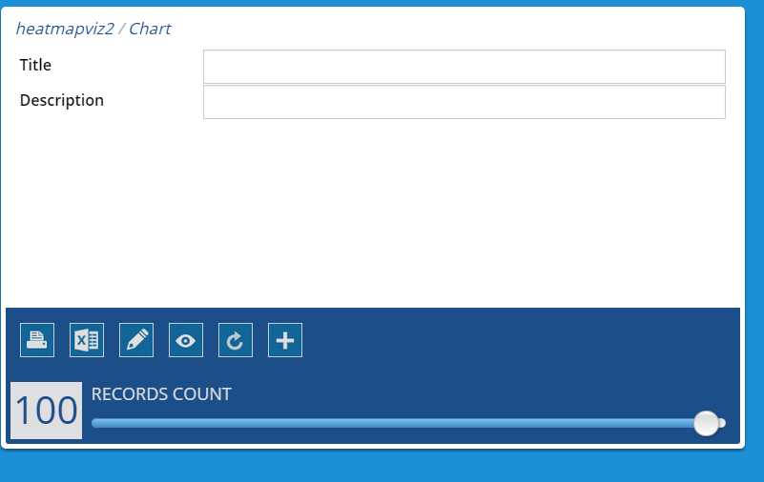
Tile Options menu

The additional following menu items are available for use on the back of each dashboard tile
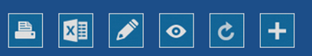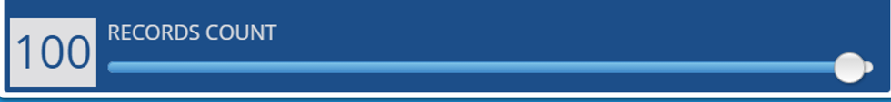
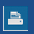 | Prints the individual report part
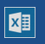 | Exports the individual report part to .xls
 | Opens the report part in report designer
 | Opens the report part in report viewer
 | Refreshes the individual report part
 | Add a new report part
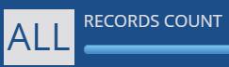 | Change the number of records displayed in the report part. This does not impact how many records are returned from the database, but only how many records are displayed on the tile.

Main Dashboard Menu
This menu offers the following menu options are available from the menu button in the top left navigation bar when expanded

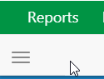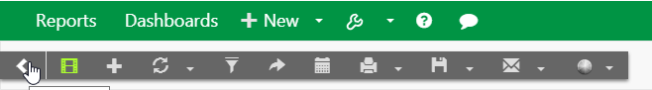

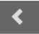 | Collapse Menu
 | Presentation Mode – Allows the user to scroll through the Dashboard tiles in a carousel
 | Create a New Dashboard
 | Icon is to refresh data. Note: Data is refreshed as defined by Aspen Grove
 | View Filters – Each report in the dashboard must share the same filter to be displayed
 | Share Dashboard with other users
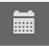 | Schedule Dashboard
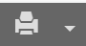 | Print Dashboard  - Print Dashboard HTML  - Print Report PDF
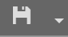 | Save Dashboard  - Save Dashboard  - Save Dashboard as
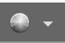 | Change Dashboard Background  - Change Background Color  - Select Background Color Rotate  - Select Image for Background

Data Sources Tab

The Data Sources tab shows you which Tables or Views you have access to from the database.
Any data source(s) selected for a report will make all columns within those sources accessible in the report designer. A report does not need to use all of these columns, they are simply made available for use.

Advanced Mode

In Advanced Mode, you will have to select the relationships that exist between the tables or views yourself. You will start with a drop-down menu that lists the various Tables and Views that are available.

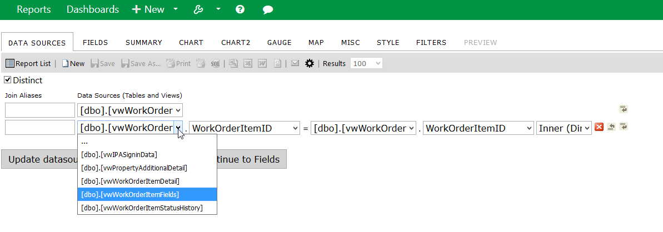

To join two tables and/or views, they must have fields with identical entries.

The Join Type dropdown menu (below) is a list of the available joining methods. The “Inner”
method discards any objects from the joint fields that do not have an identical match. The “Left” method still displays those without an identical match

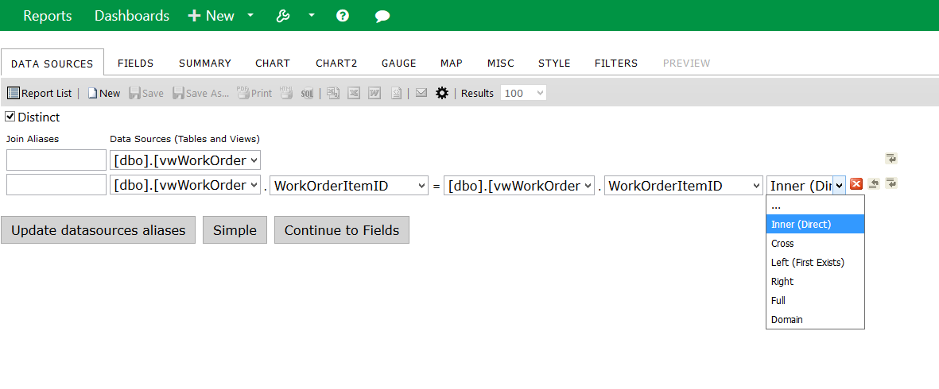
Join Type Dropdown Menu (hidden by default)

Join Types

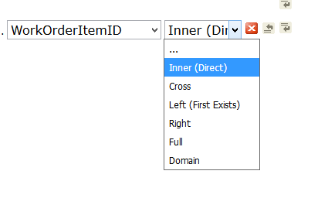

By default, Aspen iAnalytics™ will perform an Inner Join across the data sources selected.

Function Buttons of Data Sources Tab

Function Buttons
The, , and function buttons are defined in Table 2 below.

Icons | Control Name | Description
 | Delete button | Click this button to delete the row the button is on.
 | Insert Row button (above) | Click this button to insert a row above the row the button is on.
 | Insert Row button(below) | Click this button to insert a row below the row the button is on.

Function Buttons of Data Sources Tab

Fields Tab

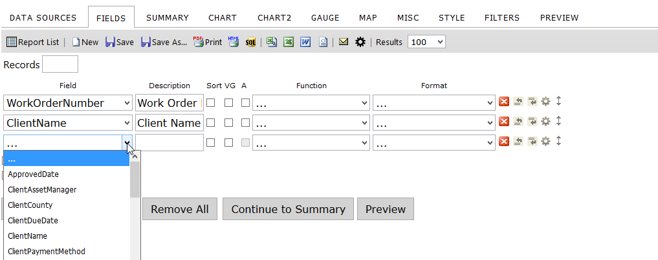
Fields Tab
After selecting the datasources you want to display, as in the previous step, continue to the Fields tab.
In the Fields tab, you will choose which fields you want to display and be able to apply various formatting options.
Listed below is a brief description of the properties available in the main Fields tab screen.

Feature | Description
Field Selection | Select fields from the drop-down menu or use the Quick Add button
Description | Displays a new title for the Field
Sort | Sorts A - Z
VG | Visually Groups the Field
A | Arithmetic – Performs basic calculations (+, -, x, %) and concatenation of text.
Function | Displays functions available based on the type of data being accessed.
Format | Displays the formats available to be displayed based on the data type.
Other buttons | On the far right you can delete, insert, move, or set advanced properties.
Records | Sets the number of records to display, which is used many times to add a Top to the query result, such as Top 10 Customers by Revenue
Add Sub-total | Adds a sub-total to the report under each numeric column
Add Side-total | Adds a side-total to the report beside each numeric row
Quick Add | Allows you quickly add multiple fields to the report at one time
Add Pivot | Displays the pivot inputs to add to the report
Continue to Summary | Continues to the next tab in the report design process, the Summary tab.

Field Dropdown Menu

The Field dropdown menu is a list of the available fields in the table/view that is selected in the Datasources tab. If joining tables/view, the title of the table/view that the field is from appears in parenthesis next to the name of the field. Select the fields to display. The entries in the list that are in Bold are the table/datasource names.

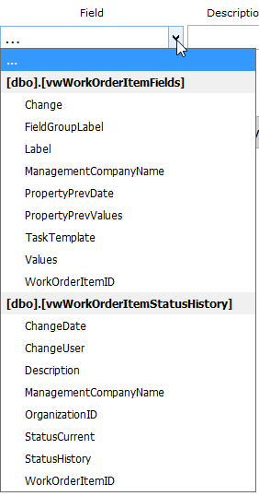
Field Dropdown Menu

Description

Automatically Inputs the name of the associated Field. You have the option to change the description and it will appear as the new title when displayed.

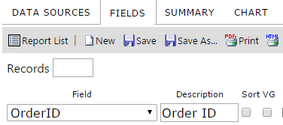

Description

Sort, VG, & Arithmetic Check Boxes

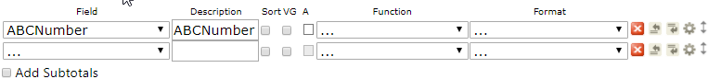

Sort, VG, & Arithmetic Check Boxes
Table 3 explains the Sort, Group, and VG Check Box features.

Features | Description
Sort check box | Check this box if you want the table/view to be sorted by the field selected in the Field dropdown menu to the left in ascending order.
Sort (z-a) under Advanced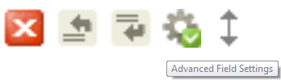 | This check box is in the advanced properties of the row and can be set if you want the table/view to be sorted by the field selected in the Field dropdown menu to the left in descending order.
VG check box | Check this box to change the column for the field selected in the Field dropdown menu to the left into subheadings
Arithmetic | Arithmetic. Performs basic calculations (+, -, x, %) and concatenation of text.

Descriptions of Sort, Group, and VG Check Boxes

Analysis Grid
Analysis Grid is a hierarchical visual group display option. Like all visual groups, it permits more than one field to be toggled as a visual group. However, instead of displaying each visual group as a combination of the values drawn from selected fields, Analysis Grid displays a collapsible hierarchy with dynamic subtotaling on every level.
In this example, we have selected State,County, and Zip as our Visual Group fields. In the Style tab, we have also changed the Visual Group Style to Analysis Grid. This is our result:
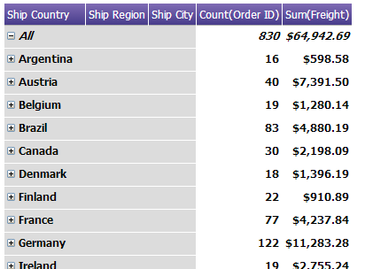

The first thing to note here is that at the top, there is a pseudovalue labeled All. This value is a built in grand total, and represents the aggregate of Countdistinct(WorkOrderNumber) for all given values of State, County and Zip. Note also the collapse buttons – the All value is expanded, and the highest level categories are all collapsed. We can click on these buttons to expand that category, and get more detail about the subordinate levels of data.
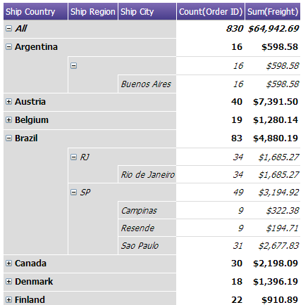
In the above example, we have fully expanded the tree for both Argentina and Brazil. First, note that there is no Ship Region value for Argentina. This value is blank, but we can still expand it anyway. Also, note that the country Argentina, the blank region, and city Buenos Aires have the same values to the right for Order ID and Freight. This is because in this data, Buenos Aires is the only city in blank region, which in turn is the only region in Argentina. The same is true with Rio de Janeiro in the RJ region of Brazil.
One final thing to note is that the data structure from left to right of City, Region, State is established in the report designer. Any fields flagged as Visual Group fields in the designer will be read top-to-bottom and displayed left-to-right in the viewer. If we had the fields City, Region, Country in top down order, then the leftmost column here would be city – which would have limited functionality using this VG style. Aspen IAnalytics™ will not automatically establish the proper data hierarchy, so it is important for the user to understand the data and how fields relate to one another to prevent top-down information from being displayed bottom-up.

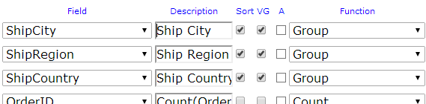

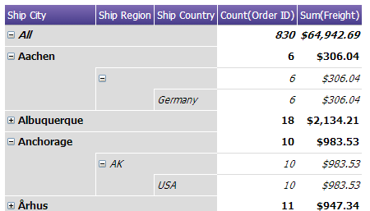

Field Order and Advanced Field Controls

Table 4 describes the function buttons of the Fields tab.

Icons | Control Name | Description
 | Delete button | Click this button to delete the row the button is on.
 | Insert Row button (above) | Click this button to insert a row above the row the button is on.
 | Insert Row button (below) | Click this button to insert a row below the row the button is on.
 | Move | Allows user to move a row up or down in the list
 | Advanced Properties | Advanced properties for that row.

Table 4 Function Buttons of Fields Tab

Functions Drop-Down
Functions allow you to perform calculations on the data and can be chosen from the dropdown menu based on the data type of the selected Field.

Text (String) Functions Available

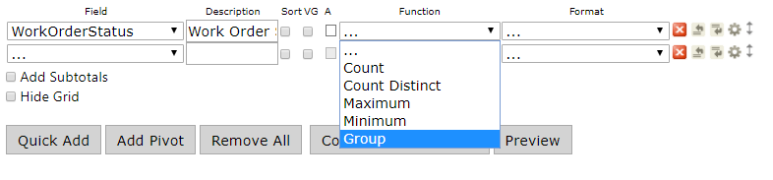

Date/Time Functions Available

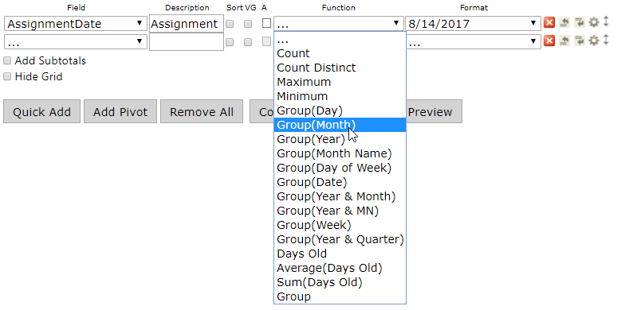

Numeric Functions Available

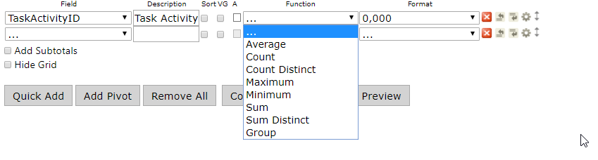

Functions Table

Function Name | Description
. . . | No function used
Average | Average the values in a column
Count | Counts the number of values in a column
Count Distinct | Counts the number of distinct values in a column
Maximum | Takes Maximum value of a field
Minimum | Takes Minimum value of a field
Sum | Sums the values in a column
Sum Distinct | Sums the rows with distinct values in a column.
Group | Groups field values together for aggregating
Group(Day) | 23; day of month
Group(Month) | 3; instead of March
Group(Year) | 2012
Group(Month Name) | July
Group(Date) | 7/4/2012
Group(Day of Week) | Sun or Mon
Group(Year & Month) | 2012 -07
Group(Year & MN) | 2012 - Jul
Group(Week) | Jul 01 – Jul 07 (Sunday to Saturday of Week)
Group(Year & Quarter) | 2012–Q3
Days Old | 342 (Number of Days from Today’s Date)
Sum(Days Old) | 782 (Sums the Number of Days from Todays Date)

Format Dropdown Menu

The Format dropdown menu is a list of formats for the entries of the field selected in the Field dropdown menu directly to the left to appear in. Depending on the Field data type and the function, you will have differing options for formatting. The main two formats used will be available for all numbers and dates.

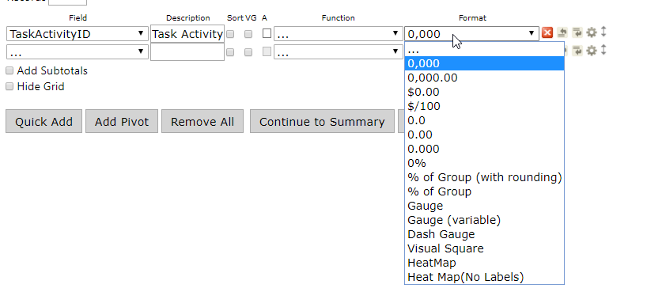
Format Dropdown Menu

Format Dropdown Menu

Numeric Formats Available

Format | Description | Examples
. . . | Displays the number as it is stored in the database | 500
0,000 | Displays as a whole number | 500
0,000.00 | Displays with two decimal places | $500.00
$0.00 | Displays as currency with two decimal places | $500.00
$/100 | Displays the Number / 100 In currency format. | $5.00
0.0 | Displays with one decimal place | 500.0
0.00 | Displays with two decimal places | 500.00
0.000 | Displays with three decimal places | 500.000
0% | Displays the number as a percentage | 50000%
% of Group (with rounding) | Same as % of Group but rounds to closest tenth (ex. 1.11547% would be 1.1%). | 100.0% (only one selected value, 500)
% of Group | Calculates the percentage of the row value to the entire group of values. | 100%
Gauge | Shows value in a Linear Gauge instead of a numerical value. This value is fixed between 0 and 1, similar to the percentage formatter.
Gauge (variable) | Shows values in a Linear Gauge which changes range based on subsequent values. The formatted field supplies the value to be gauged, the next two numerical fields establish (respectively) the lower and upper boundaries of the gauge. This gauge only operates in a range based on significant digits, so 0 to 100, 10 to 10,000, 100 to 10,000, etc.
Dash Gauge | Shows values in a Radial Gauge style with a range based on the higher number of significant digits - so a value of 1,043 will produce a range from 0-10,000, a value of 10,430 will produce a range of 0 to 100,000, etc.

Date/Time Formats Available
Format | Description | Examples
. . . | Displays the date as it exists in the database | 7/4/2012 12:00:00 AM
Short Date | Displays date using the mm/dd/yyyy format | 7/4/2012
Long Date | Displays the day of the week, month, numeric day, and the year | Wednesday, July 04, 2012
Short Time | Displays time as hh:mm AM/PM | 12:00 AM
Long Time | Displays time as hh:mm:ss AM/PM | 12:00:00 AM
Full(short) | Displays the Long Date format, followed by the Short Time format | Wednesday, July 04, 2012 4:34 PM
Full(long) | Displays the Long Date format, followed by the Long Time format | Wednesday, July 04, 2012 4:34:52 PM
D&T (short) | Displays the Short Date format, followed by the Short Time format | 7/4/2012 4:34 PM
D&T (long) | Displays the Short Date format, followed by the Long Time format | 7/4/2012 4:34:52 PM

Date/Time Formats Available

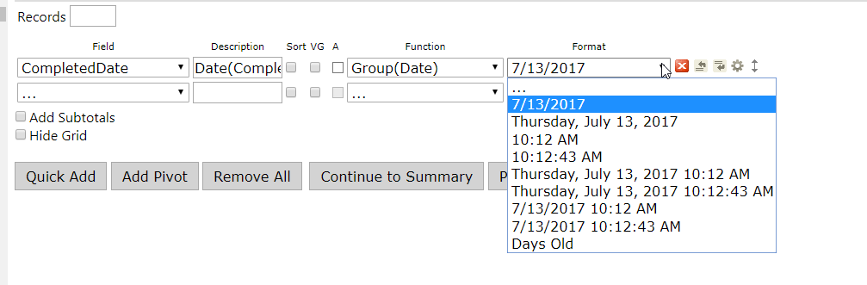

Date Format Dropdown Table

Advanced Field Settings Button

To access the Advanced Field Settings, click on the Gear icon on the selected Field.
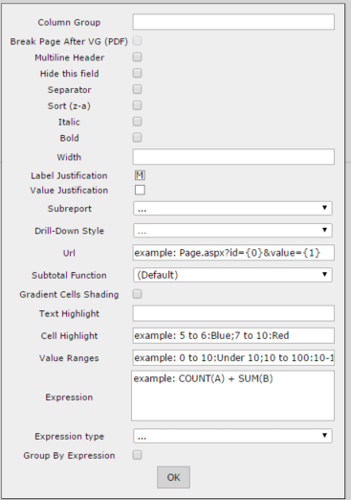

Setting Name | Description
Column Group | Applies a label to this column that can work over multiple consecutive columns. Any other column that shares the same label will be included in the grouping.  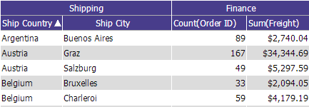
Page Break After Field | If 'Page Break After Field' box is checked and this field is also a visual group, then it will trigger a page break in a printed report every time this field has different value.
Multiline Header | 'Multiline Header' allows a header to be multi-lined if the length of the header is longer than set width of the column. Each space between words works as a line breaker
Hide this field | Hides the field from display when report the is ran. Useful for using expressions on multiple fields but when only one of the fields should be displayed.
Separator | Breaks out Analysis Grid by this field. Functions identically to VG in a normal table. Since VG is used to define the hierarchy of the Analysis Grid, Separator should be used to visually group the Analysis Grid.
Sort (z-a) | Sorts in descending order
Italic | Sets whether the column is shown in italics
Bold | Sets whether the column is shown in bold
Width | Set the width of the column in number of pixels
Label Justication | Sets the Column label to the left, right, or middle of the row
Value Justication | Sets the Value of the field to the left, right, or middle of the row
Subreport | Sets the drill-down child report. The list contains only reports that have a drill-down key set for them.  Note: The "Automatic" option will attempt to choose a sub-report by matching the drill-down key to the selected field and cannot discern between two sub-reports that use the same drill-down key.
Drill-Down Style | Link – opens in same browser window  Link (New Window) – opens in new browser window  Embedded – embeds the drill-down results into the main report  Popup – opens the results on a pop-up screen  Hover - Shows the sub-report when you hover the mouse over the item that the sub-report is linked to  ComboKey - Used in combination with one of the above. When this setting is chosen for the second drilldown key, the value of both fields will be passed from the main report to the sub-report.  Header Link - Used in a pivot to pass the value of the header (a value derived from the grouping of the pivot header column) to a subreport. Additional values from the left side of the pivot can be passed using ComboKey, or can be incorporated and hidden into the pivot itself.
Url | Allows you to define a custom Url to redirect to when the value in this cell is clicked. You can set whether this url opens in the current tab or a new tab.
SubTotal Function | Sets a customized function for subtotals displayed with this field. The default value is "Sum". This only applies to the bottom sub-totals and not the side sub-totals. If set to 'Expression' then a box will appear allowing you to set an expression for the subtotal. This functions in the same fashion as the typical expression box.
Gradient Cells Shading | Sets whether cells will use a gradient or solid colors for shading. The larger the value in the cell is, the darker the shading will become. This gradient is determined by establishing a range of x to y, where x is the lowest value in the column and y is the highest, and shading them proportionally where x will be the lightest shade and y the darkest.
Text Highlight | Highlights the text for a given range. You can refer to the Styles tab for a list of valid colors or using an RGB hex code such as #ff0033. Syntax is given in the format a to b:color;c to d:othercolor:e to f;anothercolor and so on. For example: "5 to 6:Blue;7 to 10:Red". A colon is used to separate the range and value, semicolons are used to separate pairs of range:value arguments. A value given without a range after the first range:value pair acts as a conditional, for example: "1 to 10:Red;Blue" would color values between 1 to 10 red, and everything else blue. A range may be a single value. You may also use percentages to establish a range, such as 0% to 20%:Red.NOTE: It is easy to end your statement with a semicolon like this: "1 to 10:Red;11 to 20:Blue;" This will throw an index error!
Cell Highlight | Highlights the entire cell for a given range. This follows the same rules as text highlight. You can use both cell and text highlight at the same time to provide contrasting colors, for example if you change the cell to a dark color you might change the text in that cell to a lighter color.
Value Ranges | Allows you set text values for number ranges. (i.e. setting this to 0 to 10:Under will display the text "Under" when it encounters a value between 0 and 10 for that column). This follows the same rules as text highlight.
Expression | Allows you to define a customized mathematical or SQL expression to show as the value for the column cells.
Expression Type | Allows you to specify the data type of this field. This is most useful when you are generating output with an expression and need to specify a data type.
Group By Expression | If checked, this field will be included in the group by statement of the query. This is functionally the same as the Group function, except applicable to expression output within a field rather than to the field itself.

Expressions
In the Advanced Settings popup menu (accessed by clicking the gear icon on the right-hand side of each field dialog in the Fields tab) we can see a text box called Expressions.

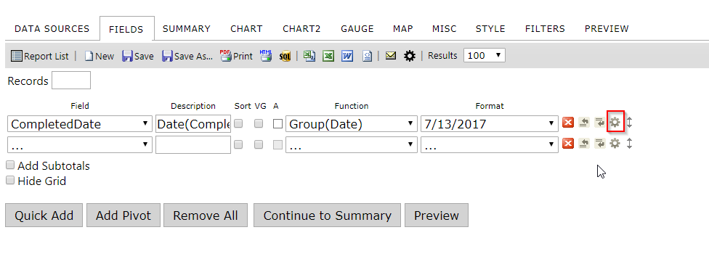
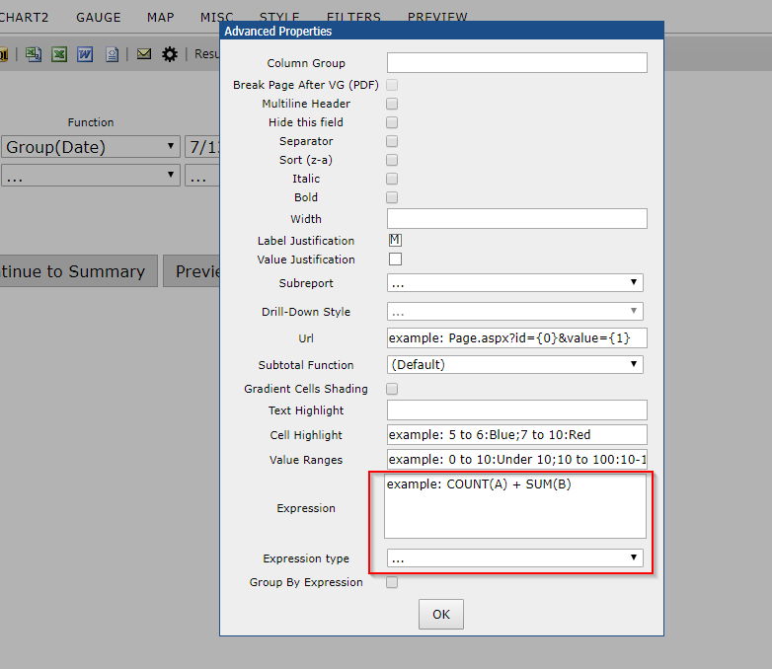
This box accepts simple code which allows us to perform calculations on fields provided by the connection string or view.
An expression cannot be run on another expression. Since there can only be one layer of expressions, to process complex multipart equations some amount of calculation must be done by using a computed column from within a view.
Expressions can:
- Add, multiply, subtract, or divide two or more existing fields
- Convert integers into ratios based on other numerator/denominator fields
- Concatenate or add text to field output
- Apply conditional logic using case/when

Expressions cannot:
- Create new ad-hoc fields
- Accept the input of another expression

Three Ways to Apply an Expression to a Field
Each of these expressions operates independently of the specified field, which is ‘Freight’ in this example. Let’s say we want to get half of the freight value. We can specify the field in the expression in different ways – naming the field directly, using the {0} operator. The Expressions text box overrides the values of the field selected- so any field can be used to create calculated columns.
In the Expressions text box in the Advanced Settings popup for the Freight field, we could write these expressions in different syntaxes to compute (½ * Freight) = x:

.5 * {0} => Result is .5 * Freight

.5 * Freight => Result is .5 * Freight

Either of these examples will work to compute (Freight/2). The first example will work when applied to the Freight field only.

If we enter the second variant in the Expressions box for another field (such as UnitPrice), then the expressed value:
.5 * [Freight] => Result is .5 * Freight

The expression box overrides any unit price data with the entered formula, displaying (½ * Freight).
It is not necessary to use square brackets, or parentheses, but using them is best practice to organize expressions and prevent syntax issues.

Text Concatenation
We can also use expressions to manipulate text. Let’s say that we have PropertyState, i.e. OH, as well as PropertyCounty i.e. Delaware. Using the following expression:
[PropertyState] + ‘, ‘ + [PropertyCounty]

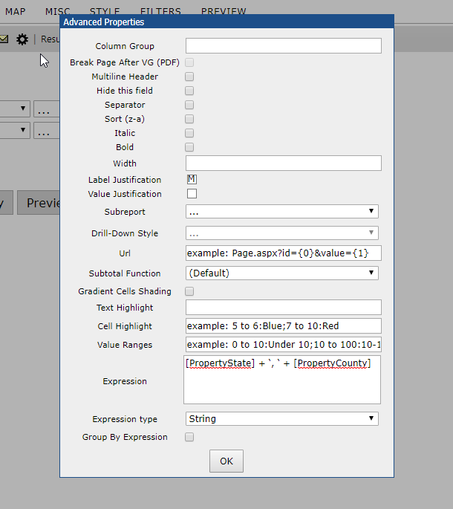
This would combine ‘OH’ and ‘Delaware’ to ‘OH, Delaware’. Note that in order to add text, we use single quotes. Anything between single quotes will appear exactly as typed, in this case a comma and single space.

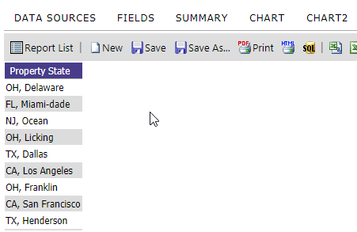
In the same as in the example, we can add a static text denomination to a numerical value.
[Freight] + ‘USD’ -> xxxxUSD
We could also write:
‘$’ + [Freight] -> $xxxx

Using [brackets] to call [table].[field]
Sometimes it is necessary to specify a table to pull fields from, where there may be fields with identical column names in different tables. In this case, we use brackets to identify the table from which we are pulling a field. In this example, we get Freight from the Orders table and the sum of the UnitPrice from the Order Details table.
[Orders].[Freight] + sum([Order Details].[UnitPrice])
Again, it is only necessary to do this if there is more than one column with the same name. If there is also a UnitPrice field in the Orders data source with different, non-pertinent data, then the above expression would be necessary to specify which UnitPrice column we want fields from.

Ratios
We can use arithmetic to get a percentage of one value compared to an aggregate value. The following expression determines the percentage of an order’s cost paid for shipping:

([Orders].[Freight])/(([Order Details].[UnitPrice]) * ([Order Details].[Quantity])+([Orders].[Freight]))

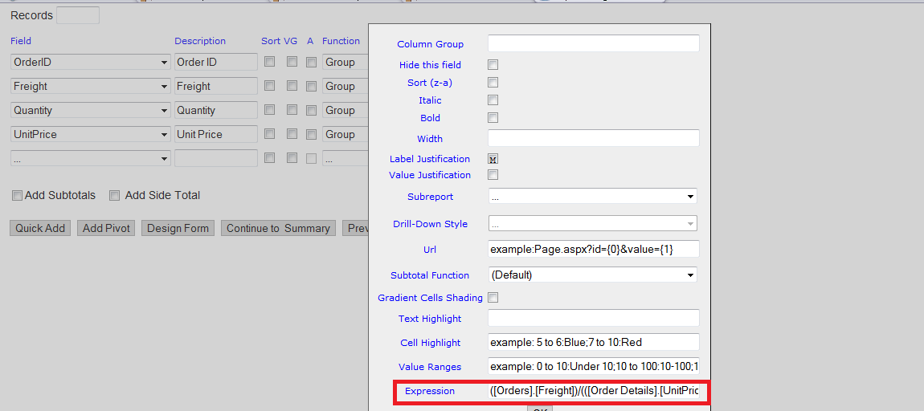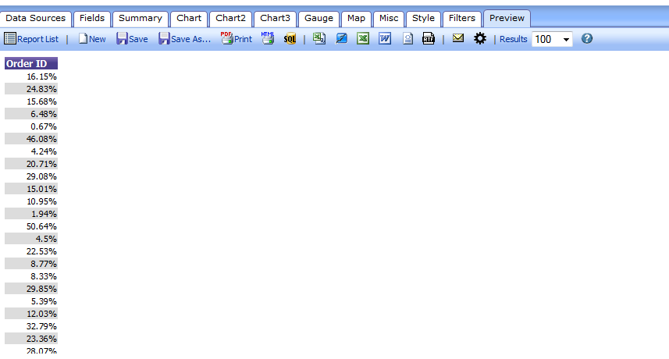
The above expression would return a decimal output. For example, if Freight were $10 and the total sum of UnitPrice*Quantity were $90, then 10/(90+10) = .1 as our result. Aspen iAnalytics™ will read this as a numeric value, so all that is necessary to turn this into a percentage is to select the ‘%’ format from the Formats dropdown for this field.

Caution: The Limits of Expressions
However, this is where we encounter a limitation on expressions. The above expression will produce correct results for each product in the order. Since the data necessary for this expression comes from multiple data sources (Orders, Products, and Order Details in the Northwind DB) it is necessary to use key variables – in this case, OrderID – to link the tables. Also, each OrderID has multiple associated ProductID to represent multiple products in each order. It is not possible to specify variables from within an expression. The net result of our expression will produce the UnitPrice*Quantity for a single ProductID on each line. It will not sum the total UnitPrice*Quantity values for multiple products within an order.
If we break the total equation into steps, the problem becomes clearer:
Step 1: Calculate UnitPrice*Quantity for each ProductID within an OrderID.
Step 2: Sum these calculated values into a hypothetical TotalUnitPrice for the OrderID.
Step 3: Add Freight to TotalUnitPrice and divide Freight by this value to get a percentage freight cost of total order cost.
Since expressions cannot create fields, but only display calculations based on fields, expressions cannot execute step 2. Steps 1 and 2 should be calculated in a view, which would create a computed column that can be used in an expression for step 3.

Functions
Functions currently available are:

avg(OrderID) produces the average of all OrderID values.

cast(OrderID, type) converts a value from one data type to another. This should only be done when you do not want to make a permanent change to the data type, such as converting numeric to strings and concatenating them. More information about using this function can be found here:
count(OrderID) produces a count of all OrderID values.
distinct(OrderID) produces a list of all distinct OrderID values.

isnull(OrderID, x) checks to see if there is a null value in OrderID and replaces it with ‘x’.
length(OrderID) returns the length of a string. Length is used with an Oracle db. If you’re using SQL, see len(OrderID).

len(OrderID) returns the length of a string. Len is used with a SQL db. If you’re using Oracle, see length(OrderID).

max(OrderID) produces the maximum OrderID value within a given range.

min(OrderID) produces the minimum OrderID value within a given range.
round(OrderID, x) takes a decimal value and rounds it to x digits.

sum(OrderID) produces the sum of all OrderID values.

Quick Add

Quick Add lets you add multiple fields to the report at one time by selecting from a list.

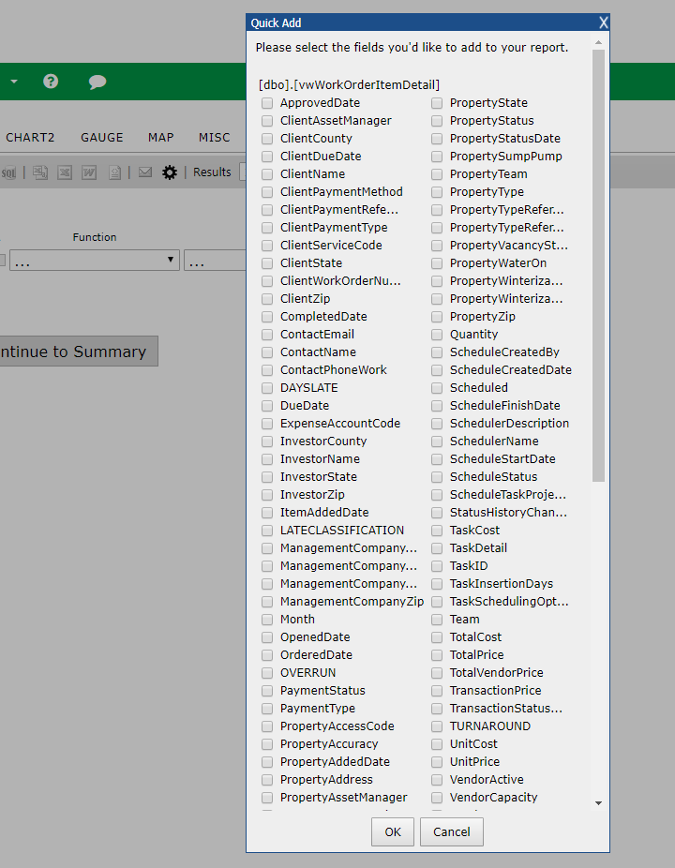
Fields Quick Add

Add Pivot

Add Pivot lets you generate a pivot attached to the right side of the tabular report. This pivot is always on the right side of the fields tab – nothing is further to the right of the pivot. You may add one and only one pivot on the fields tab, meaning that you may have one and only one pivot per report.

The first thing you must do is select the pivot columns. Values in this field will be used to generate the main columns in your pivot. You can thing of this as rotating an entire field 90 degrees, from vertical to horizontal.

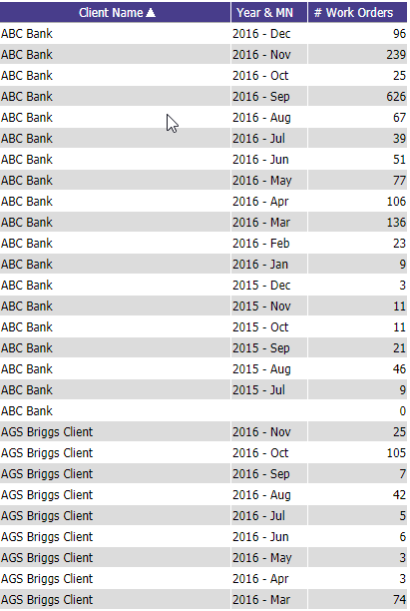
Up above: Un-pivoted tabular data by country by year. Above: Data by country, pivoted by year
You must then select at least one column to calculate cell values. These are the values which will be displayed inside of the pivot. You may select more than one column to calculate cell values – each of these will be an independent sub-column generated for each value of your pivot column header.

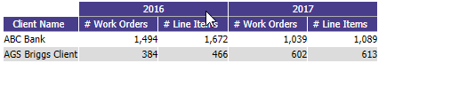
Multiple columns being displayed in a pivot per year (per pivot column value)

While you may only have one pivot, you can graphically break this pivot up by using visual groups. This will also impact the calculation of sub and side totals.
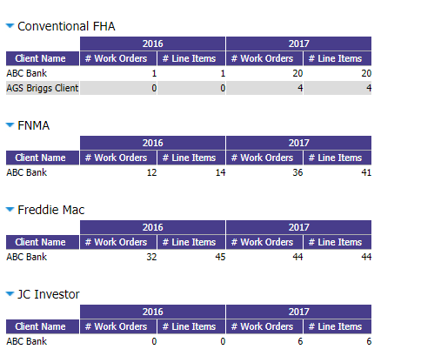
A pivot being divided by visual grouping

Filters Tab

In the Filters tab (Figure 5-1), the fields of the table/view chosen in the Data Sources tab can be filtered so that only pertinent entries appear in the table.

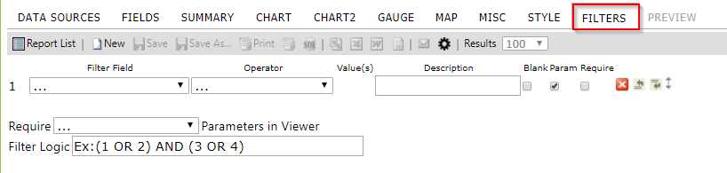

Figure 5-1 Filters Tab

Filter Field Dropdown Menu

The Filter Field dropdown menu is a list of the available fields in the table/view that have been selected or created in the Data Sources tab. Select the fields to filter. If joining tables/view, the title of the table/view that the field is from appears in parentheses next to the name of the field.

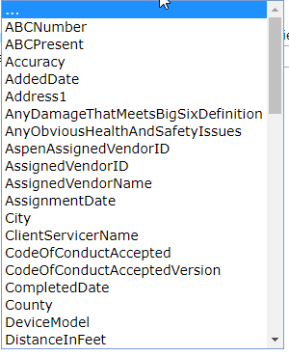
Figure 5-2 Field Dropdown Menu

Filter Operator Dropdown Menu and Value(s)

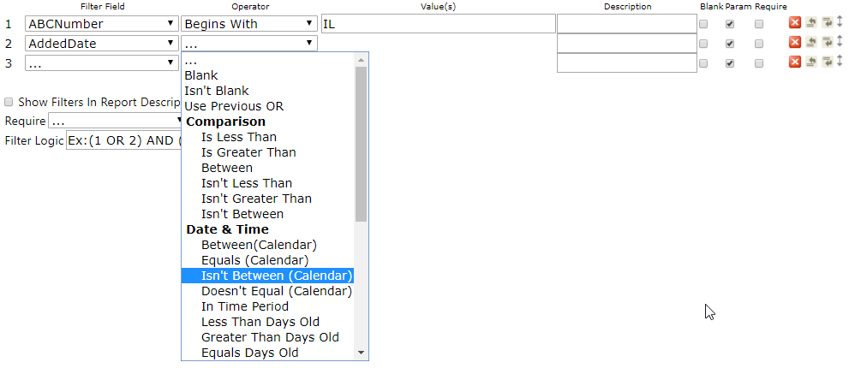

The Filter Operator Drop-down lets you select your operator based on the data type that has been selected in the filter. the filter fields available are only those under the Tables or Views selected in the Data Sources tab.

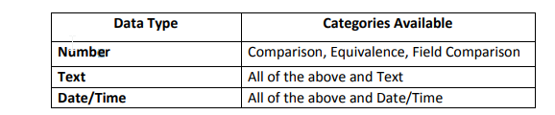

Operator Categories

Type | Filter | Description
Comparison | Is Less Than | Displays only items whose values are less than the input values.
Comparison | Is Greater Than | Displays only items whose values are greater than the input values.
Comparison | Between | Displays only items whose values lie between the input values.
Comparison | Isn't Less Than | Displays only items whose values are not less than the input value.
Comparison | Isn't Greater Than | Displays only items whose values are not greater than the input value.
Comparison | Isn't Between | Displays only items whose values are between the input values.
Equivalence | Equals | Manual text entry of the comparison value(s) separated with commas for easy copy/paste from CSV.
Equivalence | Equals(List) | Manual text entry of the comparison value(s) separated by intelligently parsed delimiters. User delimiter use must be consistent. For example of consistent use: 1, 2, 3, 4 or 1-2-3-4 or 1 2 3 4
Equivalence | Equals(Autocomplete) | Manual text entry of the comparison value(s) that displays a list of options as you type. Separate each value with a comma.
Equivalence | Equals(Select) | Allows you to select a single value from a dropdown list.
Equivalence | Equals(Multiple) | Allows you to select multiple values from a scrollable list. Use ctrl+click to highlight multiple values (command+click on Mac).
Equivalence | Equals(Popup) | Allows selection of multiple values from a popup list of checkboxes.
Equivalence | Doesn't Equal | Exactly the opposite of equals.
Equivalence | Doesn't Equal (Select) | The opposite of Equals (Select).
Equivalence | Doesn't Equal (Multiple) | The opposite of Equals (Multiple).
Equivalence | Doesn't Equal (Popup) | The opposite of Equals (Popup).
Field Comparison | Is Less Than (Field) | Allows you to compare one field to another. Determines if the first field is less than the second field.
Field Comparison | Is Greater Than (Field) | Allows you to see if one field is greater than another field.
Field Comparison | Equals (Field) | Determines if one field value equals another. This is useful for joining tables on multiple fields.
Field Comparison | Not Equals (Field) | The opposite of Equals(Field).
Date/Time | Between (Calendar) | Allows you to select two dates from a calendar popup to filter on. This filter is inclusive - any dates equal to or between the specified values will be included.
Date/Time | In Time Period | Allows you to select from a list of time periods to filter on.
Date/Time | Less Than Days Old | Allows a single numeric entry to represent the days and uses that as a filter.
Date/Time | Greater Than Days Old | The opposite of Less Than Days Old
Date/Time | Equals Days Old | Filters on records that are only as many days old as you specify.
String | Like | Determines if the value of the field contains the given text.
String | Begins With | Determines if the value of the field begins with the given text.
String | Ends With | Determines if the value of the field ends with the given text.
String | Isn't Like | The opposite of Like.
Boolean | True | Determines if the value in the field is "true".
Boolean | False | Determines if the value in the field is "false". Values other than the number 1 and the text "(T|t)rue" will be interpreted as false.
Available for All | ... | Selected when no filter is used.
Available for All | Blank | Is the field blank?
Available for All | Isn't Blank | Is the field not blank?
Available for All | Use Previous OR | The filter operator "Use Previous OR" will use the previous field's filter as its own filter. Using this technique, you can require two or more fields to be filtered with only one filter. This is helpful when your database uses composite keys or when you just want to show results filtered by field A OR field B but with only exposing one filter to the users viewing the reports.

Blank Param & Required Checkboxes

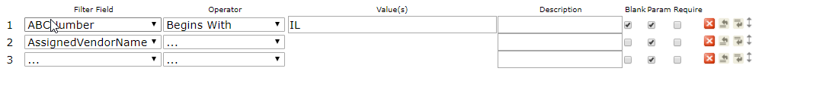
The "Blank" and "Param" checkboxes (see image above) allow you to control the filtering behavior in the report viewer. They do not affect the “Preview” tab of the report designer.
Blank Checkbox: To use this, first set a “Filter Field” and then set an “Operator”. A value can be entered, but it is not required. If “Blank” is checked, the filter will return data that matches the “Value(s)” dropdown/textbox and also data that has a null value in that field.
In the example above, if “Blank” is checked and then viewed in the report viewer, then the user would see all of the data where the “ABCNumber” begins with “IL”, or are null.
Param Checkbox: To use this, first set a “Filter Field”, set an “Operator”, and then set “Value(s)”, as in the previous example. This will display the filtered report in the report viewer and allow the user to change the filter value. If it is not checked, then the filter will not be visible to the end-user and the end-user will not be able to change the filter.

Required Checkbox: To use this, first set a “Filter Field”, set an “Operator”, and then set “Value(s)”, as in the previous example. Once this is checked, the filter value has to have results for the report to run.

Other Buttons on the filters tab
The , , , and function buttons of the Filters tab are shown below.

Icon | Control Name | Description
 | Delete Button | Click this button to delete the row the button is on.
 | Insert Row Above Button | Click this button to insert a row above the row the button is on.
 | Insert Row Below Button | Click this button to insert a row below the row the button is on.
 | Move | Allows users to move a row up or down in the list. You must click and drag until you see the space between rows is highlighted and release the mouse button to drop it.

Other Filter Features

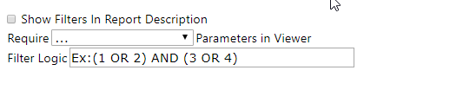
Feature | Description
Show Filters in Report Description | Adds the filters being used to the Description field of the report when the report is viewed in the Report Viewer or is exported
Require [blank] Parameters in Viewer | Sets the number of filter parameters the user must set when accessing this report in the Report Viewer.
Filter Logic (Conditional Filtering) | Ex: (1 OR 2) AND (3 OR 4). Using the example, "(1 OR 2) AND (3 OR 4)", results will be filtered conditionally based on meeting either Filter 1 or Filter 2 in addition to meeting either Filter 3 or Filter 4. You can construct extremely simple to extremely complex logic using this control. If you have a mere two filters, a simple "1 OR 2" will force your results to meet either the first or the second filter condition. Alternatively, you can nest parenthesis and combine logical operators to form sophisticated advanced filters.

Alias Filter Field Names

The filter field name can be aliased using the Description field.

Summary Tab

In the Summary tab (below), a table can be created that summarizes the chosen fields using different functions (Ex: Average, Count, Maximum, and so on). You can also make a group of fields by choosing the Group option from the Function dropdown menu.

Most actions and properties available in the Summary Tab are available in the Fields Tab.
The only difference is the removal of the Quick Add and Pivot capabilities, and addition of the Add Deltas checkbox

For more information on performing a Summary, refer to the Fields section.

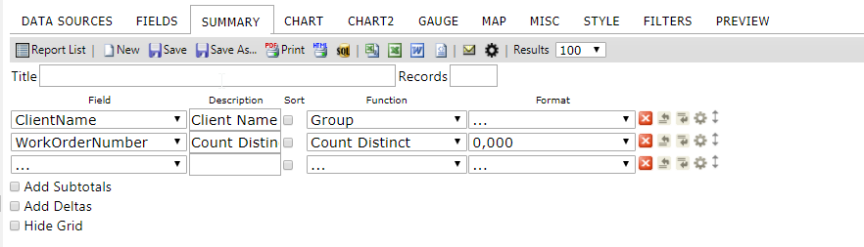
Summary Tab

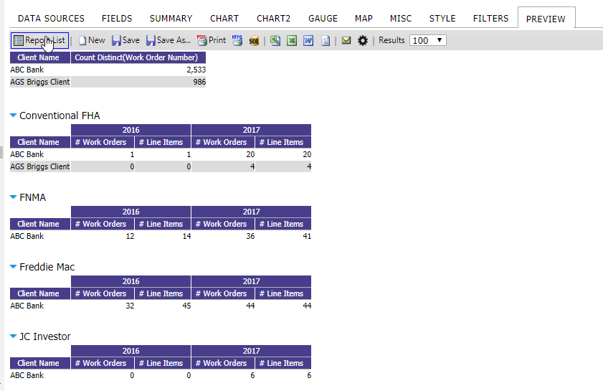
Summary Results

Chart Tab

In the Chart tab, a chart can be created using the data in the table/view selected on the Data Sources tab.

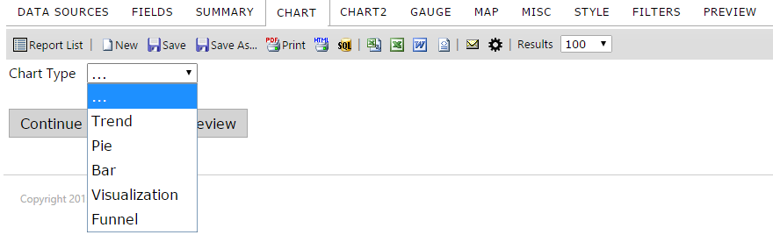

Chart Tab
The Charts Tab lets you create different variations of charts, including:

Trend
Pie
Plot
Bar
Funnel

You can have multiple charts in one report or put multiple charts of summary information on a Dashboard to show key business metrics.

None Selection

When the chart type is None (…), no chart appears.

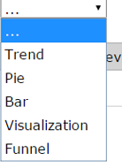
None Selection

Trend Selection

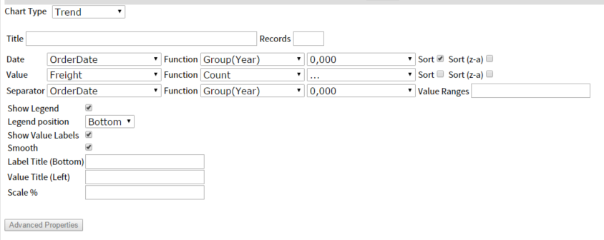
Trend Selection

The table below describes the features of the Trend chart type selection.

Features | Description
Trend chart | By choosing chart type Trend, the chart appears in Trend format.
Date dropdown menu | Will show all of your available fields that are dates
Value dropdown menu | Choose any value from the dropdown list.
Show Legend | 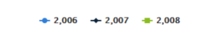
Show Value Labels | 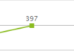
Smooth | Smoothing of the data points
Label Title (Bottom) | 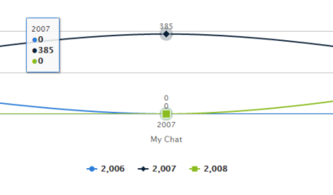  Inserts a label centered at the bottom of the chart
Value Title (Left) | 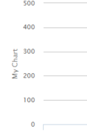  Inserts a label centered to the left of the chart
Scale % | Allows you to scale your chart to a percentage of the original size

Creating a Trend Chart showing Orders by Month

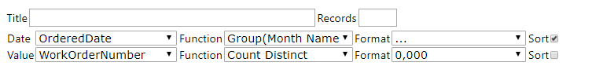
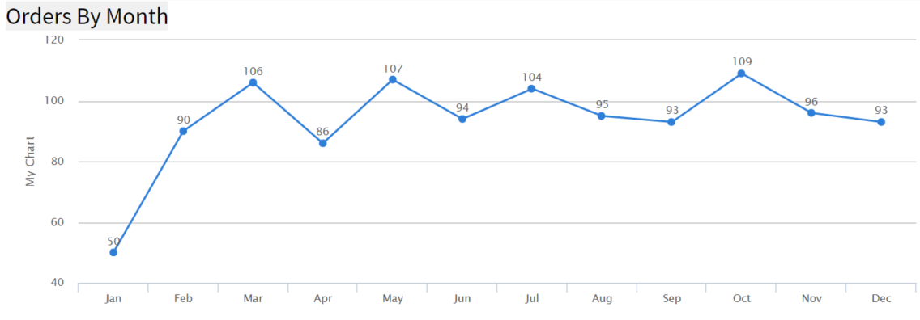

- From the ReportList.aspx page Click on "Design a New Report". Or if you are in report designer click the "New" icon. Now we need to select a data source.
- Click on the "Data Sources" tab. Then click on the drop-down box and choose "Orders".
- Click on the "Chart" tab. This is where we create charts.
- Click on the "Chart Type" drop down box and choose "Trend" for the chart type.
- Click on the "Date" drop down box and select "OrderDate" for our date field.
- For the "Date" function select "Group (Month Name)" from the drop-down box.
- Click on the "Value" drop down box and select "WorkOrderNumber" for our value field.
- For the "Value" function select "Count Distinct" from the drop-down box.
- Click on the "Preview" tab so you can view the report. Let's add a title to this report.
- 10. Click on the "Misc" tab. In the "Title" text box enter "Orders by Month"
- Click the "Preview" tab. Now the Report is titled. Let's Save it.
- Click on the "Save as" tool bar button, name your report and enter the category you want the report to be shown under. Click OK. The Aspen iAnalytics report is saved.

Creating an Advanced Trend Chart Report

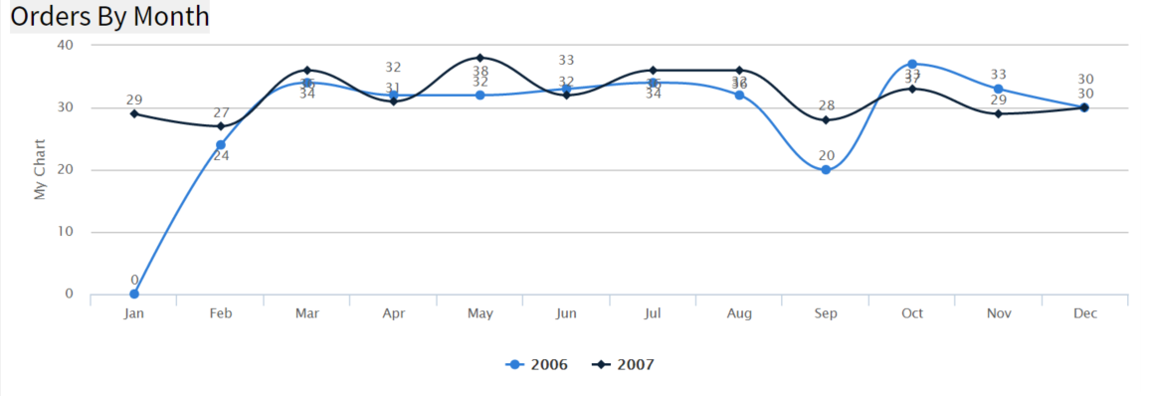
Instructions
- In report designer just click the name. In reports list you click the pencil next to the name and this will load the report in report designer.
- Click on the "Chart" tab.
- Click on the "Show Advanced" button.
- Click on the "Separator" drop down box and select "OrderDate"
- Click on the "Separator" "Function" drop down box and select "Group (year)" this is how the data will be separated.
- Notice that the legend check box is selected.
- Click on the "Smooth" check box.
- Click the "Preview" tab. Now the Trend Chart has been enhanced and separated by year. Let's update the title for this report.
- Click on the "Misc" tab.
- In the "Title" text box enter "Orders by Month and Year"
- Click the "Preview" tab. Let's Save it.
- Click on the "Save as" tool bar button, name your report.

Pie Chart

The images below show the Pie (chart) selection menu of the Chart tab.

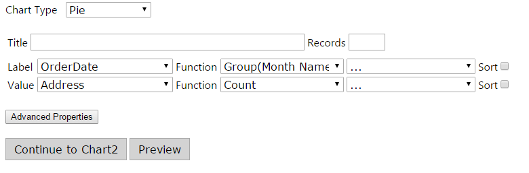

Pie (Chart) Selection

The table below describes the Pie chart selection.

Features | Description
Pie chart | By choosing chart type Pie, the chart appears in Pie format.
Label dropdown menu | Choose any label from the dropdown list.
Value dropdown menu | Choose any value from the dropdown list.

Description of Pie (Chart) Selection

Creating a Pie Chart showing the percentage of orders from each country

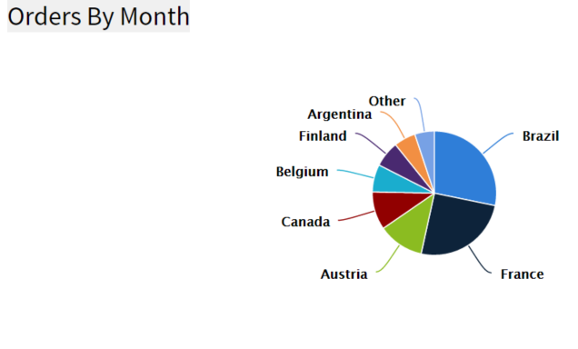
Instructions
- From the ReportList.aspx page Click on "Design a New Report". Or if you are in report designer click the "New" icon. Now we need to select a data source.
- Click on the "Data Sources" tab. Then click on the drop down box and choose "Orders".
- Click on the "Chart" tab. This is where we create charts.
- Click on the "Chart Type" drop down box and choose "Pie" for the chart type.
- Click on the "Label" drop down box and select "ShipCountry" for our label field.
- For the "Label" function select "Group" from the drop down box.
- Click on the "Value" drop down box and select "OrderID" for our value field.
- For the "Value" function select "Count Distinct" from the drop down box. Let's sort the values so the countries with the most orders will be together.
- Click on the sort checkbox for the value field.
- Click on the "Preview" tab so you can view the report. Let's add a title to this report.
- Click on the "Misc" tab.
- In the "Title" text box enter "Orders By Country"
- Click the "Preview" tab. Now the Report is Titled. Let's Save it.
- Click on the "Save as" tool bar button, name your report.

Creating an Advanced Pie Chart Report

In this lesson, we will modify the pie chart created in the pie chart above in Figure x-x by separating the data by year so we can see which countries had the most orders each year.

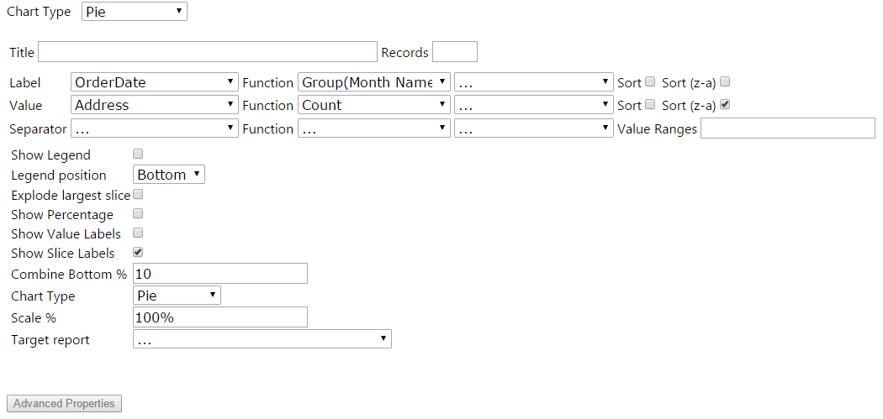

Instructions
- In reports list you click the pencil next to the name and this will load the report in report designer.
- Click on the "Chart" tab.
- Click on the "Show Advanced" button.
- Click on the "Separator" drop down box and select "OrderDate"
- Click on the "Separator" "Function" drop down box and select "Group(Year)" this is how the data will be separated. Let's limit the number of records shown to 10.
- Click on the Show records textbox. Enter 10.
- Click on the "Show Percentage" check box. Let's also change the type of pie chart.
- Click on the "Chart Type" drop down box and select "Doughnut."
- Click the "Preview" tab. Now the Pie Chart has been enhanced to show the countries with the most orders separated by year. Let's update the title for this report.
- Click on the "Misc" tab.
- In the "Title" text box enter "Orders By Country and Year"
- Click the "Preview" tab. Let's Save it.
- Click on the "Save as" tool bar button, name your report.
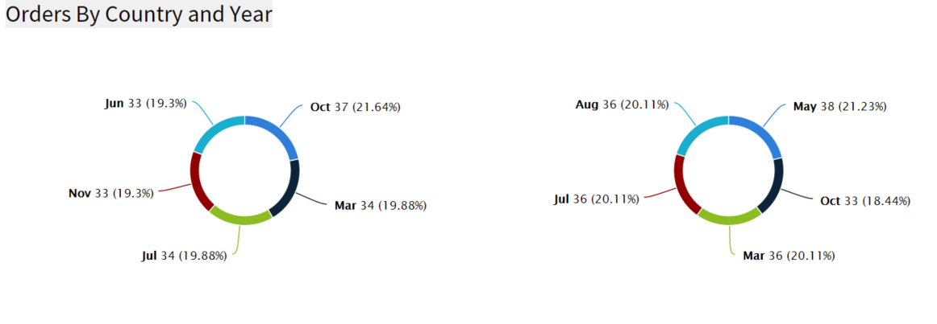

Bar Charts

The images bellow show the user selection parameters for a simple Bar Chart which counts the number of distinct orders by country.

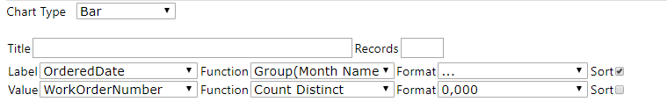
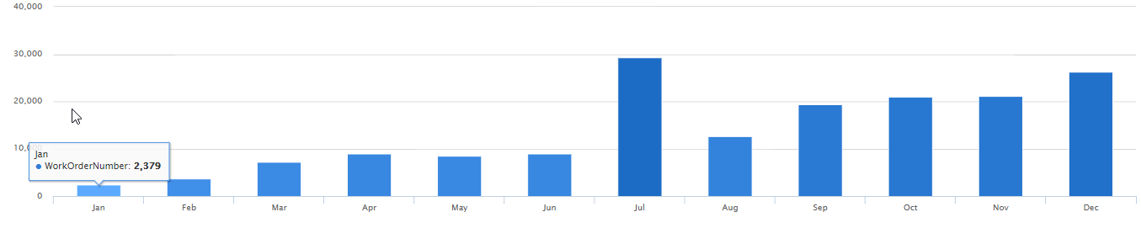

The table below describes the Bar (chart) selection entries.

Features | Description
Bar chart | By choosing chart type Bar, the chart appears in Bar format.
Label dropdown menu | Choose any label from the dropdown list.
Value dropdown menu | Choose any value from the dropdown list.

Description of Bar (Chart) Selection

Example Bar Chart

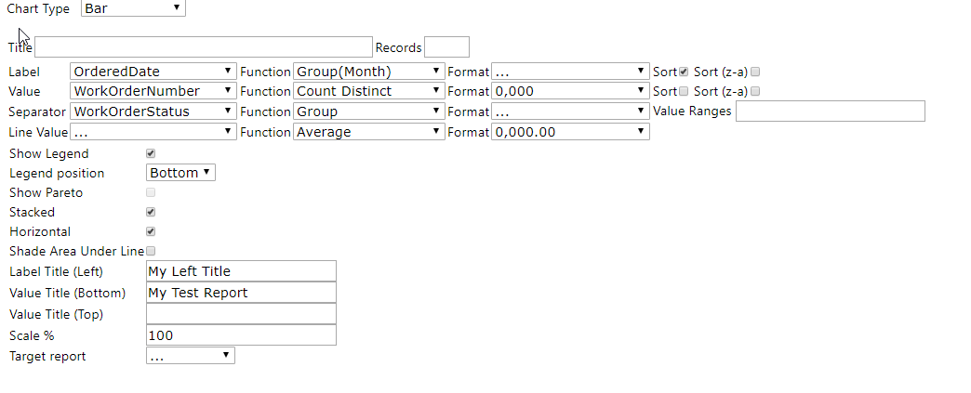

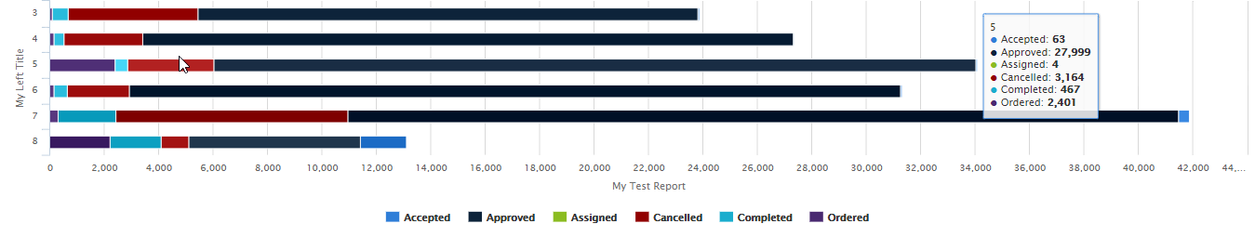

Create a Bar Chart Showing the Top 15 Countries

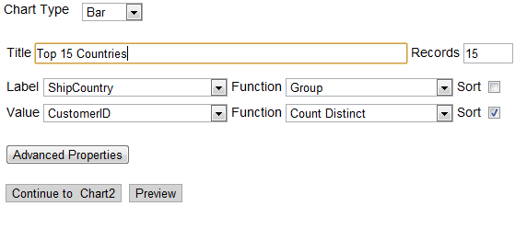

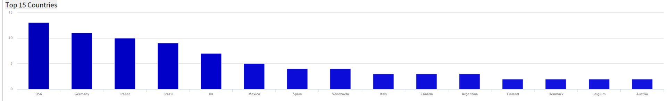

Instructions

- From the ReportList.aspx page Click on "Design a New Report". Or if you are in report designer click the "New" icon. Now we need to select a data source.
- Click on the "Data Sources" tab. Then click on the drop down box and choose "Orders".
- Click on the "Chart" tab. This is where we create charts.
- Click on the "Chart Type" drop down box and choose "Bar" for the chart type.
- Click on the "Label" drop down box and select "ShipCountry" for our label field.
- For the "Label" function select "Group" from the drop down box.
- Click on the "Value" drop down box and select "CustomerID" for our value field.
- For the "Value" function select "Count Distinct" from the drop down box. Let's limit the number of Countries listed on the graph to 15.
- Click on the Show records textbox. Enter "15". Let's sort the data so we get the Top 15 countries sorted by number of customers.
- Click on the sort checkbox for the value field.
- Click on the "Preview" tab so you can view the report. Let's add a title to this report.
- Click on the "Misc" tab.
- In the "Title" text box enter "Top 15 Countries"
- Click the "Preview" tab. Now the Report is Titled. Let's Save it.
- Click on the "Save as" tool bar button, name your report, for example "Lesson 3-1", and enter the category you want the report to be shown under, for example "Training", click ok. The report is saved.

Create a Bar Chart with a Separator

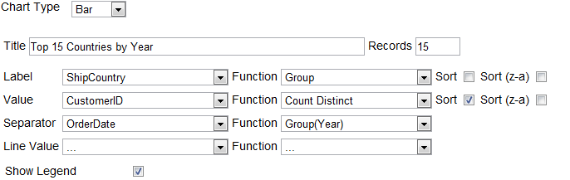

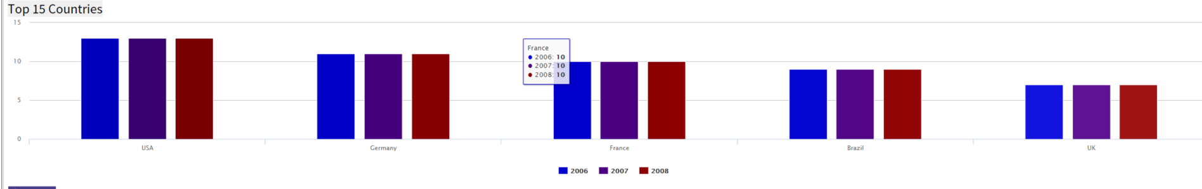

Instructions

In this example, the goal is to modify the bar chart created in the preceding example by separating the data by year so we can see who the top customers were each year.
- If you did not just complete lesson 3-1 then you will need to load it. This can be done from the reports list or report designer. It will be under the "Training" category and labeled "Lesson 3-1". In report designer just click the name. In reports list you click the pencil next to the name and this will load the report in report designer.
- Click on the "Chart" tab.
- Click on the "Show Advanced" button.
- Click on the "Separator" drop down box and select "OrderDate"
- Click on the "Separator" "Function" drop down box and select "Group (Year)" this is how the data will be separated.
- Notice that the legend check box is selected.
- Click the "Preview" tab. Now the Bar Chart has been enhanced to show the countries with the most customers separated by year. Let's update the title for this report.
- Click on the "Misc" tab.
- In the "Title" text box enter "Top 15 Countries by Year"
- Click the "Preview" tab. Let's Save it.
- Click on the "Save as" tool bar button, name your report.

Other Bar Chart Options

Show Pareto
In a Pareto chart, lines are implemented to show the trend.

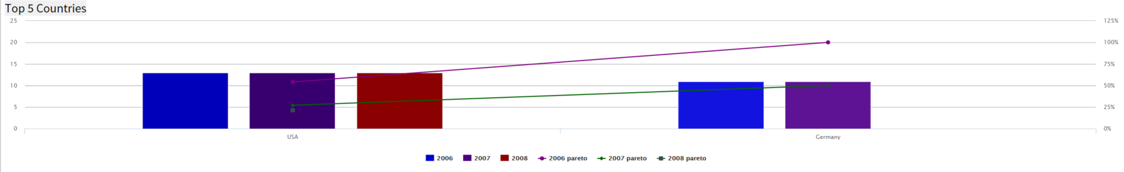

Stacked

Stacked bar graph is a graph that is used to compare the parts to the whole. The bars in a stacked bar graph are divided into categories. Each bar represents a total.

If the Stacked bar graph feature is not turned on, please contact your system administrator and ask them to validate this setting, AdhocSettings.AllowStackedBarChart = true;

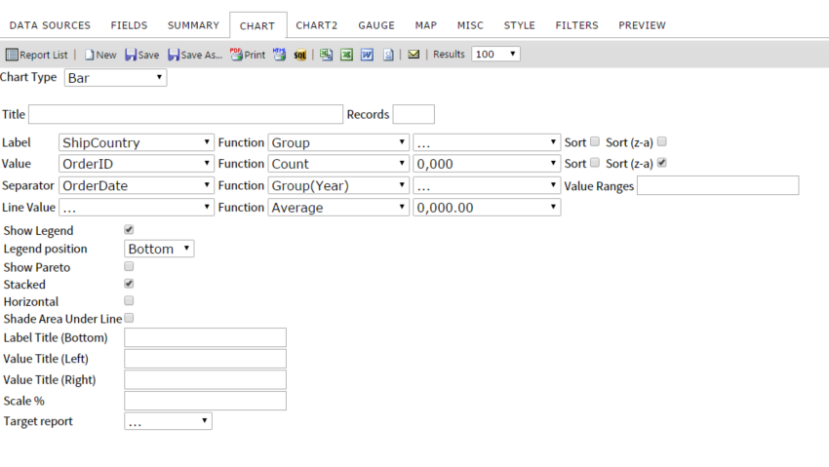
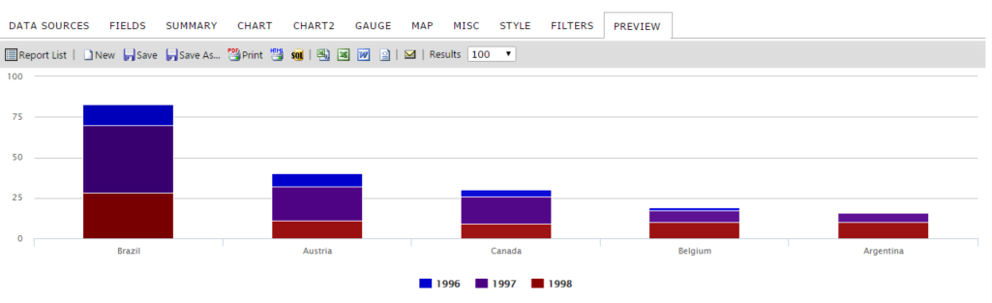

*Report filtered by selected countries to simplify

Horizontal

The selected bar chart will display the Label horizontally.
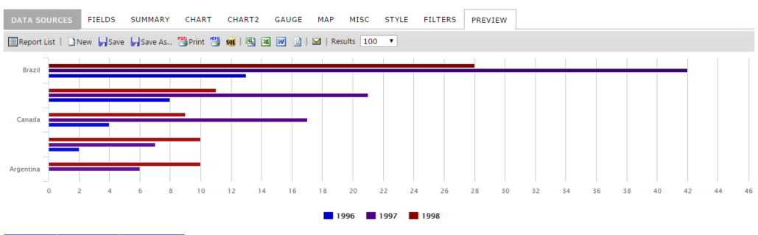

Funnel Chart

The images below show the Funnel chart selection of the Chart tab.

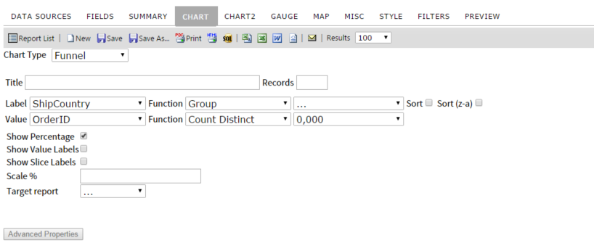

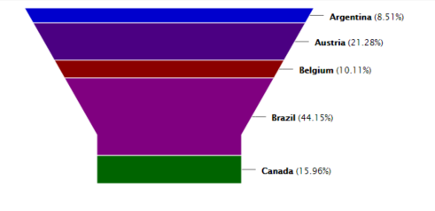

Visualizations
Visualizations are a D3-based visual supplement to our core charting engine. Visualizations are rendered in a chart report part, but are built on the columnar data in your summary or fields tab. These columns must be arranged in a specific order to provide valid data for certain visualizations. This document lists which column arrangement works with each visualization style.
Given that visualizations rely on the teamwork between the chart itself and the column data which supports it, this means that visualizations may not be easy to include in a complex report. Currently, any data in the Summary tab will be read, and if this tab is empty, the Fields tab will be used instead.

In Aspen iAnalytics™ terms, a field and a column are the same thing. This documentation will refer to fields and columns interchangeably. To be precise, fields are listed from top to bottom on the Fields tab, and displayed as columns from left to right.
Field Order
When creating a visualization, you must pay specific attention to the field order. This is the idea that fields, from top to bottom, can be numbered - the first field in the list is 1, the second field is 2, and so on. Likewise, the leftmost column is column 1, the column immediately to the right is column 2, and so on. This field order is critical, as visualizations demand a specific order to fields which dictates not only if they will be used, but how they will be used.
Field Order and Group Hierarchy
Some visualizations permit multiple group fields. Group field hierarchy must be placed in proper field order! This means highest category first, and lowest category last. Here are some examples:
Country, State/Region, City, Neighborhood

Company, Department, Office, Desk

Tera, Giga, Mega, Kilo

Expressions read the exact field order as you define it. If I place Neighborhood before Country, my visualization will not make any sense by definition! Double check that fields are in the correct order if the visualization does not appear to be correct.

Field Sorting

Visualizations sort in an order defined by the columns in the Summary or Fields tab. This order does not change if you select a different metric, which means that you can be viewing Metric B as sorted by Metric A. Currently, the only way to change the sort order is to change the sorting behavior defined by the arrangement of fields. If you are experiencing undesired or confusing sort behavior, check to make sure that the field sort order is correct.

Drilldowns and Dynamic Filtering

Some visualizations support dynamic filtering and drilldown-like behavior. Currently, a full drilldown - connecting through a visualization to another report - is not possible. A visualization can exist on a child report, and can exist on a parent report, but no part of the visualization is clickable to activate a drilldown. The drilldown terminology in this case means that some visualizations, like heatmap and sunburst, can drilldown within themselves. This is more accurately described as dynamic filtering. Dynamic filtering the visualization will also filter the linked summary or detail view.
Fields labeled with a plus (+) sign
Some visualizations can accept an indefinite number of fields as metrics. These fields are noted with a + after the field number order. That is to say, if a visualization requires 3 and only 3 fields, its fields will be listed as 1, 2, 3. However, if a visualization can have multiple fields after the first two fields which define its boundaries, its fields would be listed as 1, 2, 3+. In other words, after the mandatory fields 1 and 2, we could have fields 3, 4, 5, 6 which all serve as additional selectable metrics. Generally only one of these fields will be displayed at a time, but with the option of selecting between them.
Fields labeled with ellipsis (...)
Some visualizations can accept a large number of fields as groups. These fields are noted with a … after the field order number. This means that if a visualization accepts multiple levels of hierarchical data, I could have 5 group fields representing hierarchy in fields 1 through 5, and begin my metrics at field 6. In this documentation, this will be noted as Field 1…, Field 2. This does not mean that the metric needs to be in the actual second field. This means that the metric field(s) must be placed after all of the group fields in fields 1 through X.

Fields labeled with a question mark (?)

Some visualizations do not care where a field is, so long as it exists. These fields are noted with a ? after the field order number. This means that you don’t necessarily have to place that field in the noted order, if you have some reason not to follow the recommended best practice.
Terms
These terms refer to the types of columns that each visualization reads.

Group - This column can be any data type, aggregated or not aggregated. These columns are used to group data in other columns, and often serve as the axis or scale of a particular visualization.
Time - This column must be a Datetime data type.
Metric - This column can be any data type. It is generally an aggregate, and most commonly a numeric, but does not have to be. These columns are the elements that are being charted, mapped, or displayed on your visualization.
Geographic Field - This column is a special case. It is used in map-style visualizations. It must be a list of geographic entities, such as a list of countries, regions, or states

Arc Map

- Arc Map draws a map of the US by county. It shows two primary graphical elements - A line drawn from one city to another and a circle whose area represents the metric.
- Field 1 - Geographic Field - This field will represent the source city on the map. A line will be drawn from it to the destination city.
- Field 2 - Geographic Field - This field will represent the destination city on the map. A line will be drawn to the destination city from the source city.
- Field 3+ - Metric - This field will represent the value selectable from a dropdown.
- Notes
  - Metric fields will not graphically display if they are negative.
  - Arc Map currently only supports the continental United States.

Auto Chart

- Auto Chart permits the generation of many simple chart types. Some of these charts display a single metric at a time, others display multiple metrics at one time.
- Field 1 - Group - This field will represent the categories along the X axis, the Y axis, or the slices or items displayed on a proportional chart.
- Field 2+ - Metric - This field will represent the value on the chart. The metric currently being displayed is selectable from a dropdown.

Combo
- Combo displays metrics with a series of bars and lines on the same graph. Each metric gets its own Y axis, with the X axis determined by the single group field. The first half of the metric fields will be displayed with bars, the second half with lines.
- Field 1 - Group - This field will represent the categories along the X axis.
- Field 2+ - Metric - This field will represent the values of each bar or line. Each bar or line will receive its own scale on the Y axis.
- Notes:
  - Metric fields will be split between bar and line graphs. The first half of your metric fields will be bars, the second half will be lines.

Crossfilter
- Crossfilter displays multiple charts, one for the datetime grouping field and one for each metric. Clicking and dragging on any chart will establish a range, which acts as a filter on all other charts. You can also drag the range itself to move it without changing its size. This chart is useful for finding clusters of data within other data, for example we have less orders in June vs. August but they are worth more money.
- Field 1? - Datetime - This field will represent the time factor by which other metrics can be filtered. Range of values is displayed on the X axis and count of values is displayed on the Y axis.
- Field 2+ - Metric - This field will represent the value. Range of values is displayed on the X axis and count of values is displayed on the Y axis.
- Notes:
  - Some group categories for Datetime will produce too many or invalid results. If your chart does not work, try a different grouping on the datetime or filtering the dataset from the Filter tab.

Heat Map

- Heat Map displays a tree-like hierarchy of squares, each of which proportionally represents the aggregate metric at each level of the hierarchy.
- Field 1... - Group - This field represents the hierarchical levels which structure the heat map.
- Field 2+ - Metric - This field will represent the value on the chart. The metric currently being displayed is selectable from a dropdown.

Matrix

- Matrix displays a series of squares, arranged by group and time, in the style of a pivot. The squares are shaded according to each metric value.
- Field 1 - Group - This field will represent the categories along the Y axis.
- Field 2 - Time - This field will represent the categories along the X axis. This field must have the function set to Group(Year & Month).
- Field 3 - Metric - This field will represent the value of each square.
- Notes:
  - Matrix can only render so many squares. If you aren’t getting enough data on the time based X axis, try filtering out some items from the group based Y axis.

Projected Map
- Projected Map displays a scalable, zoomable map which ties metrics to single geographic entities.
- Field 1 - Geographic Field - This field will represent lists of countries, cities, or other entities.
- Field 2… - Metric - This field will represent the value selectable from a dropdown.
- Notes:
  - Currently only the United States is supported.

Sunburst

- Sunburst displays a tree-like hierarchy of items layered in a circular arrengement, each of which proportionally represents the aggregate metric at each level of the hierarchy. The layers from inner to outer represent each level of the hierarchy. Larger groups are displayed from the 12 o’clock position clockwise.
- Field 1... - Group - This field represents the hierarchical levels which structure the heat map.
- Field 2+ - Metric - This field will represent the value on the chart. The metric currently being displayed is selectable from a dropdown.

Time Bubble
- Time Bubble is a multidimensional graph which displays circles which change in size and position over time. Mousing over the time label at the bottom right of the chart will move forward and backward in time.
- Field 1 - Group - This field will represent each circle.
- Field 2 - Datetime - This field will determine the scale at which circles move and change size. This field must be set to Group(Year & Month).
- Field 3 - Metric - This field will represent the Y axis.
- Field 4 - Metric - This field will represent the X axis.
- Field 5 - Metric - This field will represent the Z axis, represented by the area of the circle.

Timeline
- Timeline displays a single metric between two points in time. The length of each item represents the distance between your start and end times.
- Field 1 - Group - This field represents the Y axis.
- Field 2 - Metric - This field represents the item charted.
- Field 3 - Datetime - This field represents the beginning point from which the metric will be drawn.
- Field 4 - Datetime - This field represents the end point to which the metric will be drawn.
- Notes:
  - Timeline can only display up to a fixed amount of data. If you are not seeing all the data you expect to see, try filtering down your report set - particularly the time dimension.

Transitions
- Transitions displays multiple common graph styles in a fixed cycle.
- Field 1 - Group - This field represents categories on the Y axis or slices of proportional charts.
- Field 2 - Datetime - This field represents the X axis when applicable. It must be set to Group(Year & Month)
- Field 3 - Metric - This field represents the value.
- Notes:
  - You must sort Fields 1 and 2 to make coherent charts. If your charts look odd, make sure that the sorting behavior is correct.

Waterfall
- Waterfall displays a bar chart with a built in pareto function - that is, the bottom of each bar begins at the top of the previous bar.
- Field 1 - Group - This field represents each bar along the X axis.
- Field 2 - Metric - This field represents the value of each bar.

World Tour

- World Tour displays countries and a single metric associated with that country.
- Field 1 - Geographical Field - This field represents the country.
- Field 2 - Metric - This field represents the value associated with each country.

Auto Gauge
- Auto Gauge can be used to display 3 different type of gauges
  - Simple large number KPI metric
  - Thermometer type gauge (can be positioned either vertically or horizontally)
  - Percentage KPI Gauge with filled circle value – circle size and width can be altered
- Field 1 - Group - This field represents each bar along the X axis.
- Field 2 - Metric - This field represents the value of each gauge

Calendar
- Calendar displays a month/week/day view.
- Field 1 - Group - This field represents the event title.
- Field 2 - Metric - This field represents the event value.
- Field 3 - Time - This field represents the beginning point from which the metric will be drawn.
- Field 4 - Time - This field represents the end point to which the metric will be drawn.

Flow Chart / Data Tree
- Flow Chart / Data Tree displays a tree-like hierarchy of nodes and connecting lines. Nodes are established from left to right in field order. Lines and the size of nodes are determined by the selected metric.
- Field 1... - Group - This field represents the hierarchical levels which structure the data tree.
- Field 2+ - Metric - This field will represent the value on the chart. The metric currently being displayed is selectable from a dropdown.

Gauge Tab

In the Gauge tab, you can add a panel of gauges to a report.

There are four different types of gauges you can create:
Type | Description | Image
Radial | This gauge displays a static needle that goes from 90° (straight up) to 0° (pointing right). | 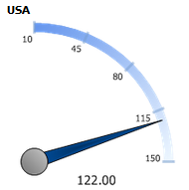
Radial 2 | This gauge is the same as the radial gauge but has a different graphical appearance. | 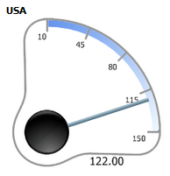
Animated Half Circle | This gauge starts from 180° (pointing left) and animates to 0° (pointing right). You can also set KPI indicators. | 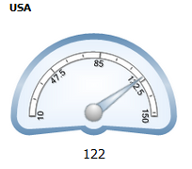
Linear | This gauge is a simple bar that fills from left to right. | 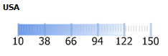

The gauges also have a number of options that can be selected. They are described below:
Feature | Appearance | Description
Title | []() | Sets a title for the Gauge section of the report.
Results | []() | Sets how many gauges should be displayed (one gauge per grouped result).
Name | []() | The name of the field to use as the Gauge's grouping field.
Value | []() | The name of the field to use as the Gauge's data points. This must be numeric.
Sort | []() | The name of the field to sort the data by. To sort alphabetically, use Maximum or Minimum.
Minimum | []() | Sets the lower bound for the gauge's display values.
Maximum | []() | Sets the upper bound for the gauge's display values.
Color | []() | Allows you to set specific colors or color ranges for the gauge's value bar. Applies to the Radial, Radial2, and Linear gauges.
Gauge Style | []() | Allows you to choose which type of gauge you want to display.
KPI Low | []() | Only available by selecting "Animated Half Circle". If set, this will set a lower bound for a "target zone" within the gauge.
KPI High | []() | Like KPI Low, but this will set the value for the upper bound on the "target zone" within the gauage.
Update | []() | Allows you to set the update frequency for the gauges. This is good for tracking dynamic data that is updated frequently.
Red Values | []() | Specifies which side of the target zone should be denoted with red. Good for indicating whether small or large values cause concern. This has three values.  Hide:This is the default. Neither large nor small zones will be considered hazard zones.  Low: Low values (Anything to the left of your target zone) will be considered hazard values and will get a red stripe.  High: High values (Anything to the right of your target zone) will be considered hazard values and will get a red stripe.
Target Report | []() | Allows you to specify a sub-report to be used with the drilldown key of the Name field. The target report will appear upon hovering your mouse over the gauge.

Create First Four Gauges Alphabetically Counting Orders by Country

The Report below is showing the first 4 gauges based on the alphabetical order of the selected countries.

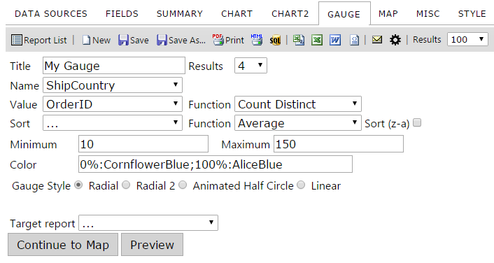

Gauge tab contents

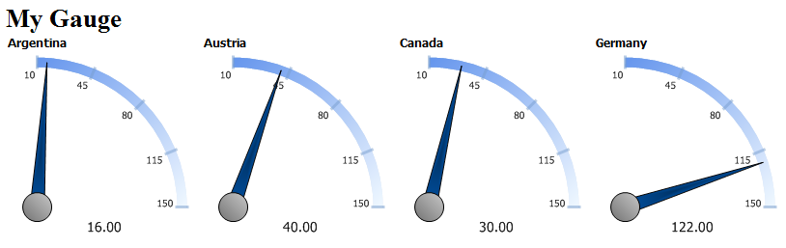

Creating the Top 4 Orders by Country Gauges

In the following example, you will see the gauges of the four countries with the greatest number of orders.

You can add four different types of gauges

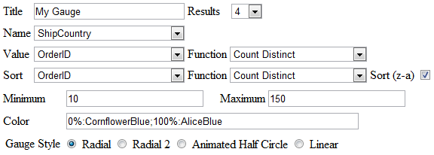

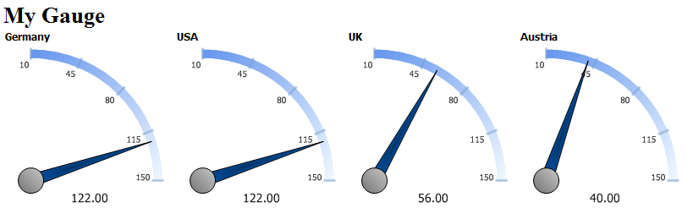

Changing Color Ranges

To change color ranges for the gauge, enter in a percentage range for each color, or enter a range of specific values.

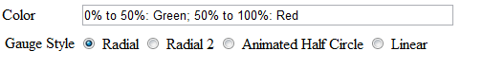

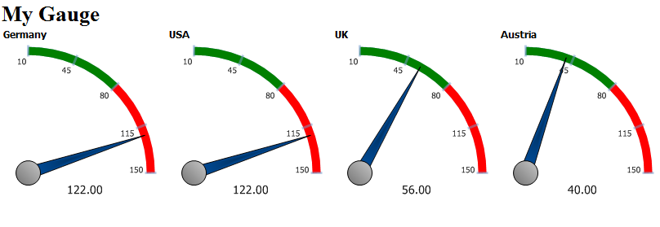

OR

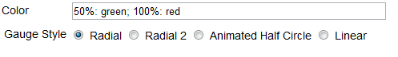

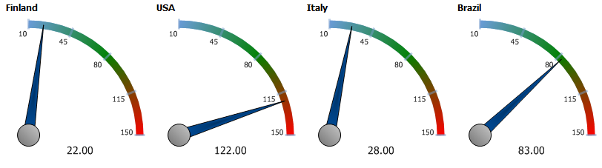

OR

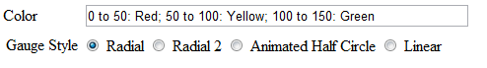

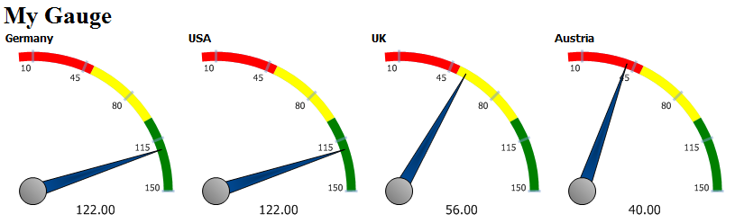

KPI’s and auto-updating data with Animated Gauges

The Animated Half Circle opens up a few more options under the Gauge Style row.
With these new options, you can select the KPI Low and High, and select whether the Red values will be hidden, on the low side, or on the high side. You can also select how update the date updates.

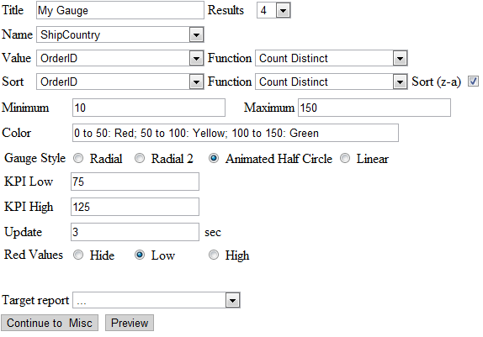

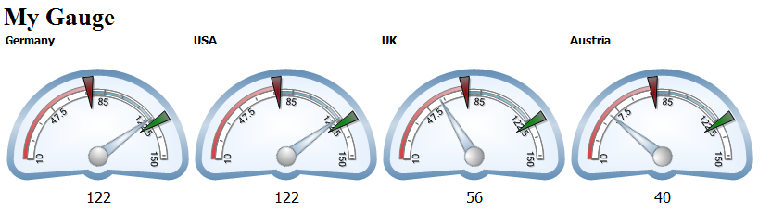

Gauges with Drill-Down Effects

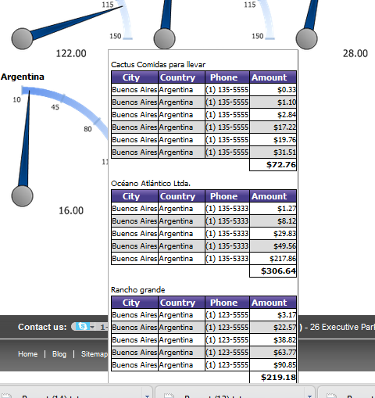

Aspen iAnalytic™ Maps

The Aspen iAnalytics™ Maps add-on provides interactive geographical visualization to the reporting experience.

In the report below, we are shading the colors of the states based on the sum of the freight, applying a hover over that shows the top products by state, and displaying an indicator bar on the location of the postal code while showing the number of orders vertically in the bar.

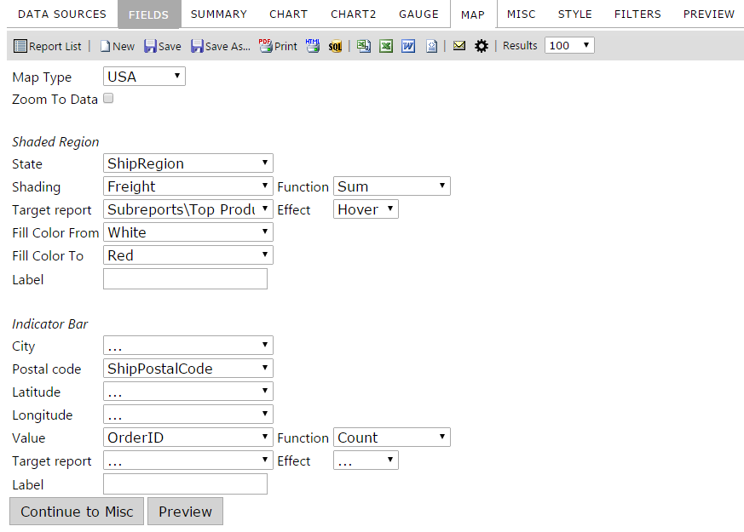

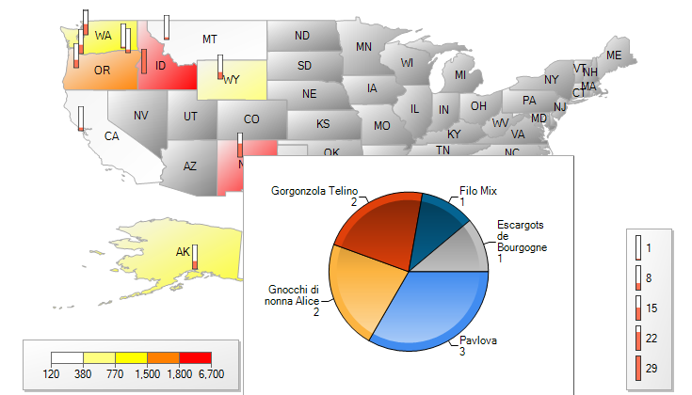
Feature | Description
Map Type | 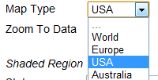
Zoom to Data | Zooms to the region or state the data is in
State | Select the field where state data is located
Shading | Selects the field and function you will use for shading
Fill Color From - To | Fills the color of the shading from a selected color to a selected color
Label (1st one displayed) | Sets the text displayed for the Legend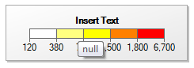
Postal Code | Select the field where postal code data is located
Latitude / Longitude | Select the field where GIS data is located for lat/long
Value | Sets the field and function you will use in the indicator bar
Label (2nd one displayed) | 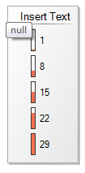

Misc Tab

In the Miscellaneous Tab (Misc Tab), you can add a title, description, header and footer to the report, all with left, middle, or right justification. Sharing and Scheduling are the two most popular features under this tab.

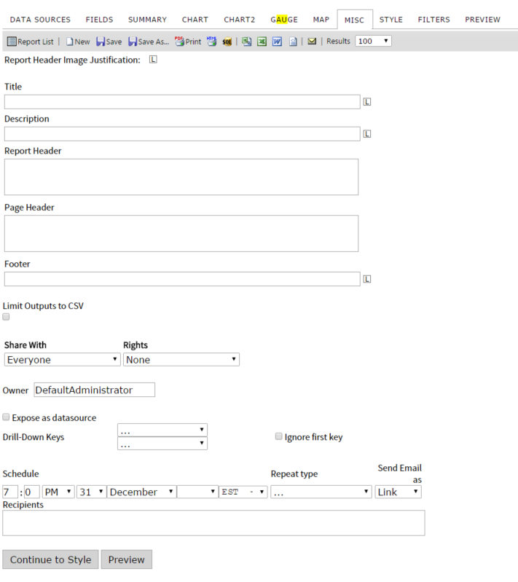
Misc tab contents

Feature | Description
Report Header Image Justification | Allows you to move the Report Header to the left, middle or right.
Title | Enter the title of the report.  Examples below use “INSERT TEXT” as input.  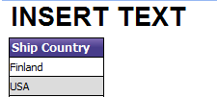
Description | Enter a description for the report.  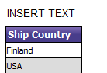
Header | Allows a user to set a report header.
Footer | Allows a user to set a report footer.  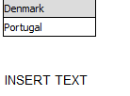
Limit Outputs to CSV | If checked, disables all forms of export other than CSV
Expose as datasource(must be enabled by admin, may not be visible to you)  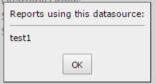 | This allows the report to be published as a datasource. The report name will show on the datasource tab and other reports can be created from this report set. This is similar to creating a view in the database without database access. This can also be used to create calculations off of calculations. Turning on this feature also alters the way the datasource page appears. All datasources will reports created from them will display as a hyperlink. Clicking on the link will display a list of the reports created with that datasource.

Share With & Rights

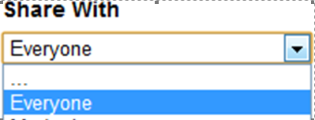
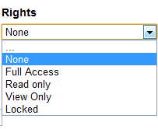

Rights | Description
…
None | Do not share this report with anyone
Full Access | Can share with every user and group
Read only | Can make changes to Save As but cannot modify the original
View Only | Cannot make any changes to the report
Locked | The report is available to users to view, and users can modify existing filters' values, but users cannot add or remove filters or fields, and they cannot save changes to the report. Users may also not change the column or operator of the filters.

Drilldowns and Subreporting

To create a drilldown report, you can start by designing the main report, but in order to be able to select a drilldown report, that subreport must first have a drill-down key to show up in the selection list. This means it often makes more sense to work from the ‘bottom up’, from the lowest subreport to the highest parent report.
A subreport will not appear in the list of available subreports until it has a drilldown key defined. Once this has been set and the report saved, any other report will be able to access the subreport in the list of available subreports. At this point you can define a drilldown style to control how the subreport is accessed.

Example

Design Sub-Report

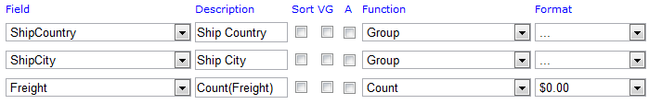

Set the Drill-Down Key under the MISC tab
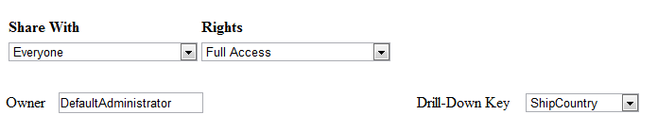

Design main report
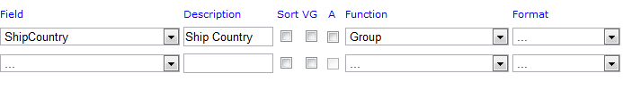

Click on Advanced Field Settings in Main Report

Select the Subreport

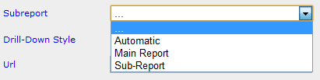

Select the Drill-Down Type

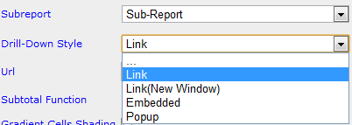

Option | Description
. . . | Disables the drilldown without removing the link between this field and a subreport
Link | Opens subreport in the same browser window
Link(New Window) | Opens subreport in a new browser window
Embedded | Embeds subreport in the table cell or directly into a form
Popup | Displays subreport in a pop-up window. You must click on the popup to clear it from the screen.
Hover | Shows the sub-report on the same screen as an overlay when you hover over the current field, chart, or gauge.  NOTE: This option is not available on the Fields Tab!
ComboKey | Indicates that this drilldown key is a second, third, or other key that is not the first key. The first key controls the drilldown style, and every other field with a target subreport and the ComboKey behavior defined will pass their value along with that first value, in field order.

Scheduler

Schedule: Set the schedule date and time.
Repeat Type: Set the repeat frequency.
Send Email As: Set the format in which the email is sent.
Recipients: Enter a comma separated list of recipients.

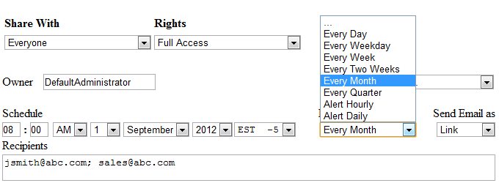

How to Set Up the Aspen iAnalytics™ Scheduler

Repeat Type

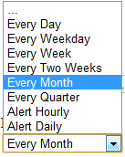

Select a time frame like Every Month.
Or select an Alert, which will send an email if filter parameters are not met.
You can also enter in custom time spans, for example, in cases of Fiscal vs. Yearly Quarters.
Send Email as

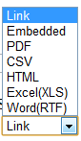

You can send the email as a number of attachments, like PDF, Word, & Excel, as a Link, which shows a link to click on in the email, or as Embedded, which embeds the report in the body of the email.

10.0 Style Tab

In the Style tab, you can customize the look and feel of the report that will be displayed. You can change the color of the border, header, and rows, as well as the order the report items.
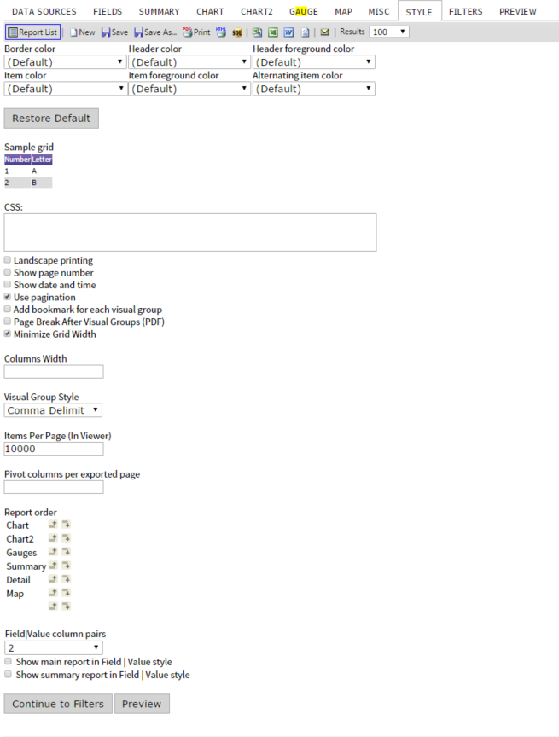

10.1 Style Properties
When you change the properties of the various colors within the report, the sample grid below can be used to see the differences.

The colors which can be changed are: Border color, Header color, Header foreground color, Item color, Item foreground color, and Alternating item color.

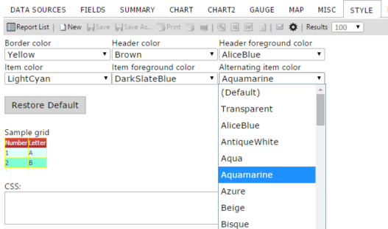

Explanations of other properties found on tab are given below.
Feature | Description
Border color | 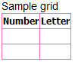
Header color | 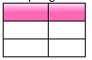
Header foreground color | 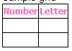
Item color | 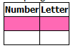
Item foreground color | 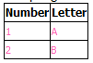
Alternating item color | 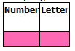
Landscape printing | Determines whether the report prints in landscape mode. (It can also be set using print properties in the printer dialogue box)
Show page number | Sets whether the page numbers are shown in PDF report exports.
Show date and time | Sets whether the date and time are shown in PDF report exports.
Use pagination in web view | Sets whether pagination is used in the report viewer.
Add bookmark for each visual group | Sets whether bookmarks are used in adobe PDF exports.
Page Break After Visual Groups | Sets whether each Visual Group will receive its own page
Minimize Grid Width | Adjusts the margins to the smallest width for each column
Visual Group Style (explained in more detail below) | 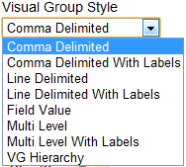
Items per page (In Viewer) | Allows a user to set the number of items shown per page in a grid.
Pivot Columns per exported Page | Sets limit on how many pivot columns are shown – creates multiple instances of the grid when printed to limit the number of pivoted columns on each grid instance.
Report Order | Allows the user to set the order of the Summary, Chart, Gauges, Map, and Detail (Field) grids
Field|Value column pairs | Allows a user to set the field value style for multiple columns displaying on one row.
Show main report in Field | Value style | Allows a user to set whether the main detail grid uses  Show summary report in Field | Value style Field-Value style
Show summary report in Field | Value style | Allows a user to set whether the summary grid uses Field-Value style

