Dear Vendor,

As you know, we require any field service provider who accesses properties in the default process to have a satisfactory background check.

To ensure we comply with industry best practice, we are using **Aspen iRecord®** to manage these background checks. Simply follow the steps outlined below to get up and running on the system. If you have an account and background check on **Aspen iRecord®** already, go directly to **STEP 5** **– Connect to Networks.**

**STEP 1 - Register Your Business Account**

Navigate to [Aspen iRecord®](https://irecordv2.aspengrove.net/applications/irecord/?logout=true). Click **Register Now** and complete the registration process by following the on-screen instructions.



**STEP 2 – Select Background Check Company**

Log into your [Aspen iRecord®](https://irecordv2.aspengrove.net/applications/irecord/?logout=true) account, select a background check company and complete their business verification process to be allowed to submit a background check. **This will take several days to process** (depending on how quickly you provide them required documentation).

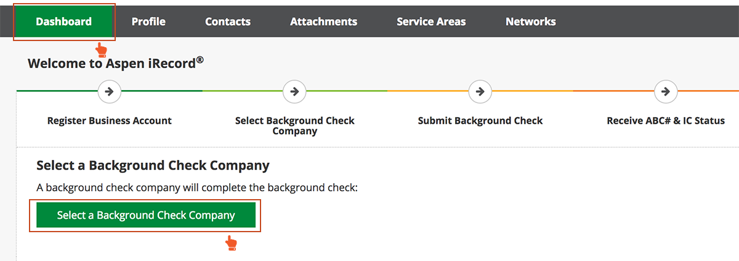

**STEP 3 – Submit Background Check**

Login to [Aspen iRecord®](https://irecordv2.aspengrove.net/applications/irecord/?logout=true), add contacts, complete necessary documents and submit a background check. **This can take several days to process** (depending on completeness and accuracy of information provided and court system involved).

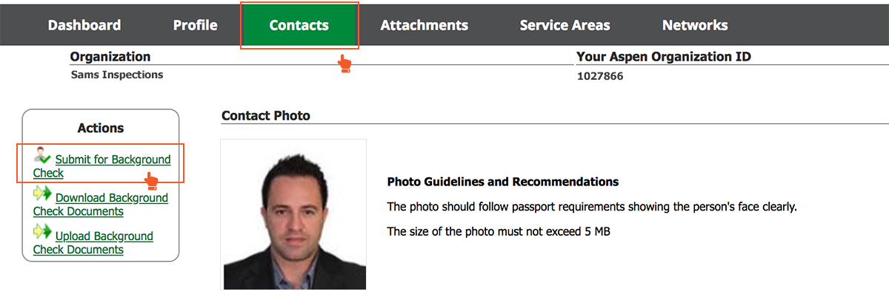

**STEP 4 – Receive ABC# & IC Status**

Once a background check is complete, contacts are assigned an **ABC#** (Assigned Background Compliance Number) and **IC** (Individual Compliance) status.

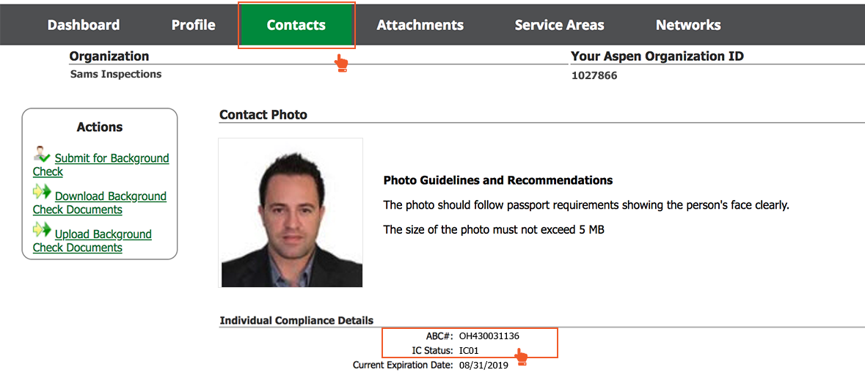

**STEP 5 – Connect to Networks**

Enter the following unique connection and verification codes into your account. This will connect your business with ours in Aspen iRecord®.

**Connection code:**  **<Insert Connection code here>**

**Verification code:**  **<Insert Verification code code here>**

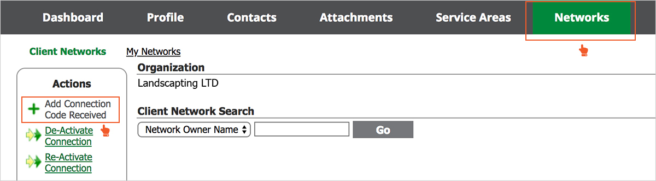

Thank you for your help during this process. We value our relationship with our field service providers, so we welcome your feedback.

If you have any questions or you would like to find out more about using Aspen iRecord® visit [Aspen Grove Solutions Customer Care](https://customercare.aspengrove.net/hc/en-us). The **Help** center has many useful articles on [how to register](https://customercare.aspengrove.net/hc/en-us/articles/228461628-Registration), [add contacts](https://customercare.aspengrove.net/hc/en-us/articles/228448828-Add-a-Contact), [submit contacts for background checks](https://customercare.aspengrove.net/hc/en-us/articles/228342707-Submit-a-Contact-for-a-Background-Check), and [use connection codes](https://customercare.aspengrove.net/hc/en-us/articles/228341947-Joining-a-Network).

Sincerely,

**<Your Business Name Here>**